**Stock Truck Module.**

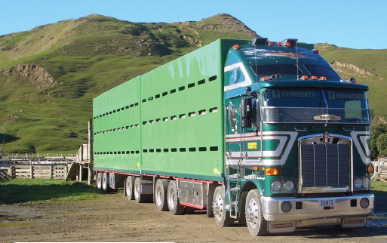A stock truck has arrived at Cape Kidnappers Station to transport some sheep. The truck is going to Hastings first and then on to Napier.

The stock truck has the flowing dimensions.

* 18.8m – total length of the pens on the truck and trailer
* 2.4m – width of the pens on the truck and trailer

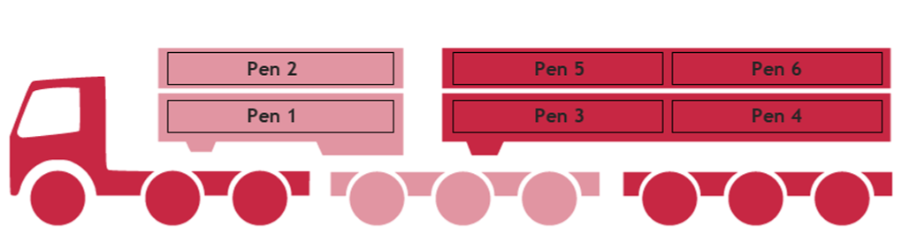The truck is a double stacker so 3 pens per layer, so, 6 pens in total (see picture).

**Loading Density Guideline for SHEEP:**

Based on animals carrying 25mm of wool

|  |  |
| --- | --- |
| **Average Live Weight (kg)** | **Minimum Space Allowance (m²/head)** |
| 20 | 0.14 |
| 30 | 0.17 |
| 40 | 0.21 |
| 50 | 0.26 |
| 60 | 0.31 |

Below shows what the groups of sheep are and where they will be going when they leave Cape Kidnappers Station.

1. 56 x 30kg shorn store lambs going to Stortford Lodge saleyards in Hastings.
2. 35 x 60kg woolly prime ewes to Progressive Meats in Hastings.
3. 11 x 40kg shorn fat lambs to Fresh Meats in Napier.

Route taken by the stock truck.

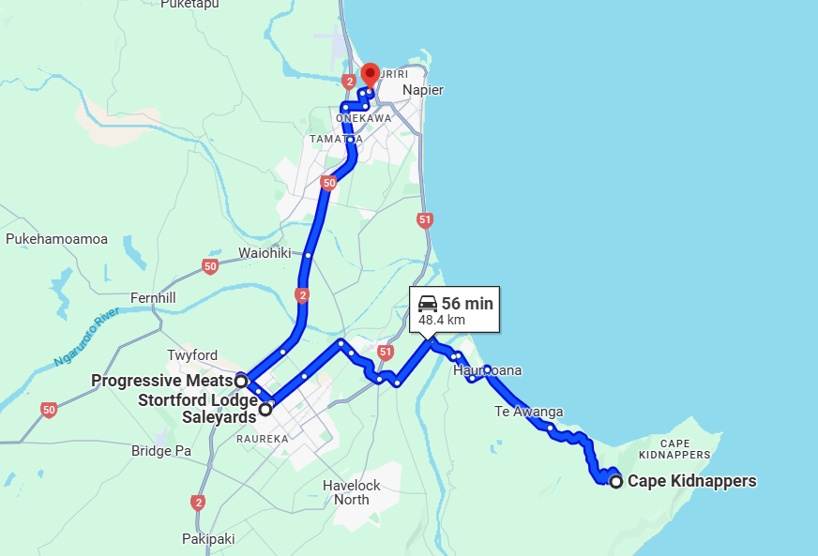

**Questions.**

For any of the calculations, you need to show your working.

Note: You cannot mix the groups of sheep.

1. What order would you load the 3 groups of stock into the truck?
2. How many m2 is the truck and trailer?
3. What is the size of the pens?
4. What is the maximum number of sheep that can be in each pen for each of the groups?
5. How many pens of sheep are needed for each group of sheep?
6. How many pens are left?
7. If Farmer Brown rings while you are in transit to Stortford Lodge saleyards and asks if you can pick up 30 x 30kg lambs and take them to the Stortford Lodge saleyards. Can you do this job on your way? Explain your answer.
8. What are the nets on the top of the truck and trailer used for?
9. How many people can safely travel in the stock truck?
10. If the truck driver was to take cattle instead of sheep, would the Minimum Space Allowance (m²/head) change?

**Answers.**

1. What order would you load the 3 groups of stock into the truck?

Load c), b), and then a).

1. How many m2 is the truck and trailer?

The truck and trailer are 18.8m (length of truck) x 2.4m (width of truck) = 45.12m2.

1. What is the size of the pens?

The size of the pens are 45.12m2 (size of the truck and trailer) / 6 pens = 7.52m2 per pen (size of pen).

1. What is the maximum number of sheep that can be in each pen for each of the groups?
   1. Maximum number of sheep = 7.52m2 (size of pen) / 0.17 (Minimum Space Allowance (m²/head) for 30kg sheep) = 44 sheep per pen.
   2. Maximum number of sheep = 7.52m2 (size of pen) / 0.31 (Minimum Space Allowance (m²/head) for 60kg sheep) = 24 sheep per pen.
   3. Maximum number of sheep = 7.52m2 (size of pen) / 0.21 (Minimum Space Allowance (m²/head) for 40kg sheep) = 35 sheep per pen.
2. How many pens of sheep are needed for each group of sheep?
3. 0.17 (Minimum Space Allowance - m²/head for 30kg sheep) x 56 sheep = 9.52m2 so 9.52m2 / 7.52m2 (size of pen) = 1.2 pens so 2 pens needed.
4. 0.31 (Minimum Space Allowance - m²/head for 60kg sheep) x 35 sheep = 10.85m2 so 10.85m2 / 7.52m2 (size of pen) = 1.4 pens so 2 pens.
5. 0.21 (Minimum Space Allowance - m²/head for 40kg sheep) x 11 sheep = 2.31m2 so 2.31m2 / 7.52m2 (size of pen) = 0.3 of a pen so 1 pen.
6. How many pens are left?

2 + 2 + 1 = 5 pens so 1 pen left.

1. If Farmer Brown rings while you are in transit to Stortford Lodge saleyards and asks if you can pick up 30 x 30kg lambs and take them to the Stortford Lodge saleyards. Can you do this job on your way? Explain your answer.

0.17 (Minimum Space Allowance - m²/head for 30kg sheep) x 30 sheep = 5.1m2 so 5.1m2 / 7.52m2 (size of pen) = 0.6 pens so 1 pen.

Yes. The sheep will need 1 pen and there is 1 unutilised pen in the truck. As the pickup is on the way, yes, they can pick up the lambs and take them.

1. What are the nets on the top of the truck and trailer used for?

Nets are used for stopping animals from jumping out. All open decks or crates shall be fitted with a cover which must be used when livestock are transported on the top deck. The cover shall be constructed and secured in such a way that it cannot dislodge, flap or create excessive noise during transportation.

1. How many people can safely travel in the stock truck?

3 people can travel in the cab of the truck.

1. If the truck driver was to take cattle instead of sheep, would the Minimum Space Allowance (m²/head) change?

Yes, the Minimum Space Allowance (m²/head) for cattle is generally more than sheep as they are bigger animals and weight a lot more, so therefore need more room in the truck. See table below.

|  |  |  |
| --- | --- | --- |
| **Class** | **Average Liveweight (kg)** | **Minimum Space Allowance (m²/head)** |
| Young Calves | 30 | 0.16 |
| 50 | 0.21 |
| 70 | 0.26 |
| 90 | 0.30 |
| Young Cattle | 100 | 0.36 |
| 150 | 0.50 |
| 200 | 0.62 |
| Adult Cattle | 300 | 0.86 |
| 400 | 1.06 |
| 500 | 1.27 |
| >600 | 1.50 |