# Sheep Measles

## What You Need to Know

Sheep measles is a disease caused by a tapeworm in dogs. The tapeworm is passed to dogs when they eat raw sheep meat. While sheep measles does not pose a risk to human health, it causes blemishes on sheep meat. These blemishes are undesirable for consumers, especially in the export market.

**The life cycle of the *Taenia ovis* tapeworm**

* The tapeworm in dogs produces eggs, which are passed out in their faeces. These eggs end up on the pasture where sheep or goats can eat them.
* After ingestion, the eggs travel through the sheep or goat’s intestines and into their bloodstream. From there, the eggs move to the muscles, where they form cysts.

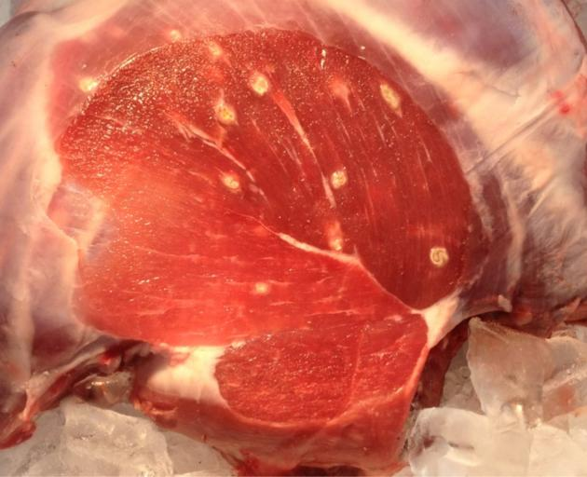

* These cysts can infect dogs if they eat the raw meat of the sheep or goat.
* Over time, most cysts are killed by the sheep’s immune system, leaving behind hard, fibrous, or calcified lesions (defects in the meat). Some cysts can stay alive for months or even longer.

**How do dogs get infected?**

* Dogs become infected when they eat raw or untreated sheep or goat meat that contains live cysts. These cysts are very infectious and hard to see.
* To avoid infection, dogs should not be allowed to eat untreated sheep or goat meat, including scraps, offal, or carcasses.

**How do sheep and goats get infected?**

* Infected dogs pass thousands of *T. ovis* eggs in their faeces onto the pasture.
* Sheep and goats eat these eggs, which can survive for months on the ground.
* Eggs can also be spread over large areas by wind or flies.
* On-farm dogs are the biggest risk, but infection can also come from visiting dogs, including those from neighbouring farms or towns.

**Why should farmers care about sheep measles?**

Although New Zealand currently has low levels of sheep measles, an outbreak can harm healthy sheep. At the meat works, this can result in downgrading or even condemning sheep carcases. This leads to financial losses for farmers. Many other countries have less effective ways of managing sheep measles, so New Zealand's “clean” sheep can be seen as superior to those from other countries.

**Reducing the Risk of Sheep Measles**

Farmers can take several steps to reduce the risk of sheep measles on their farms. By using all of these methods, farmers can help prevent infection and protect their sheep.

1. **Dog dosing:** All dogs (including pets) on the farm should be treated monthly with a tapeworm drug called Praziquantel. This drug kills tapeworms and stops sheep measles from spreading. Dogs need to be dosed every month to prevent the tapeworms from maturing (it takes 35 days for the tapeworm to mature).
2. **Safe dog feeding:** Any sheep or goat meat, including offal, should be treated before feeding it to dogs. This can be done by freezing the meat to -10°C for at least 10 days or cooking it thoroughly to a temperature of at least 72°C. Offal should be boiled for at least 30 minutes.
3. **Home killing:** When killing animals at home, do it in an area where dogs cannot get to the meat scraps or offcuts.
4. **Disposal of dead stock:** Farmers should dispose of dead livestock quickly in a way that keeps dogs from accessing them.
5. **On-farm dog control:** Dogs should never be allowed to wander. Even well-fed dogs will scavenge and could become infected.
6. **Foreign dogs:** Any new dogs should be treated with a tapeworm drug at least 48 hours before coming onto the property.

***Exercise***

1. What is sheep measles, and how does it affect sheep meat?
2. What is the life cycle of the *T. ovis* tapeworm, and how does it spread between dogs, sheep, and goats?
3. How do dogs become infected with the *T. ovis* tapeworm?
4. How do sheep and goats get infected with sheep measles?
5. Why is it important for farmers to care about sheep measles?
6. What steps can farmers take to reduce the risk of sheep measles on their farms?
7. How can dogs safely be fed meat without spreading the disease?
8. Why is it important to dispose of dead livestock properly on a farm?
9. What should farmers do when new dogs come onto the farm to prevent the spread of sheep measles?

**Answers**

1. **What is sheep measles, and how does it affect sheep meat?** Sheep measles is a parasitic disease caused by a tapeworm in dogs. It does not harm humans, but it causes blemishes on sheep meat. These blemishes are undesirable, especially for the export market.
2. **What is the life cycle of the *T. ovis* tapeworm, and how does it spread between dogs, sheep, and goats?** The *T. ovis* tapeworm lays eggs in dogs, which are passed out in their faeces and end up on the pasture. Sheep or goats eat these eggs, which then move through their intestines and into their muscles, forming cysts. Dogs can then become infected by eating the infected meat of sheep or goats.
3. **How do dogs become infected with the *T. ovis* tapeworm?** Dogs become infected when they eat raw or untreated meat from sheep or goats that contain live cysts of the tapeworm.
4. **How do sheep and goats get infected with sheep measles?** Sheep and goats get infected by eating eggs from the tapeworm, which are passed onto the pasture by infected dogs. The eggs can also be spread by wind or flies.
5. **Why is it important for farmers to care about sheep measles?** Sheep measles can lead to blemishes on sheep meat, which can cause financial losses for farmers. Meat works may downgrade or condemn infected carcasses, affecting the quality of the meat and market value.
6. **What steps can farmers take to reduce the risk of sheep measles on their farms?** Farmers can reduce the risk by treating their dogs monthly with a tapeworm drug, ensuring safe dog feeding, doing home killing in dog-proof areas, disposing of dead livestock properly, controlling dogs on the farm, and treating any new dogs before they come onto the property.
7. **How can dogs safely be fed meat without spreading the disease?** Dogs should only be fed meat that has been either frozen to -10°C for at least 10 days or cooked thoroughly to a temperature of at least 72°C. Offal should be boiled for at least 30 minutes.
8. **Why is it important to dispose of dead livestock properly on a farm?** Dead livestock should be disposed of quickly and properly to prevent dogs from scavenging and becoming infected with the tapeworm.
9. **What should farmers do when new dogs come onto the farm to prevent the spread of sheep measles?** Farmers should dose new dogs with a tapeworm drug at least 48 hours before they come onto the farm to prevent the spread of sheep measles.