Hydatids

What You Need to Know
New Zealand is one of the few countries in the world to have successfully eradicated True Hydatids, a disease that has a life cycle similar to Sheep Measles. Hydatids infect dogs when they eat offal (organ meat) from infected livestock. The parasite needs to infect dogs to complete its life cycle and reproduce. Because hydatids are a public health risk, New Zealand took nearly 50 years of efforts through rules about feeding offal to dogs and regular dog worming practices to get rid of the disease. In 2002, the Ministry for Primary Industries (MPI) declared New Zealand ‘provisionally free’ from hydatids. We still have rules about feeding offal to dogs to help stop the parasite from coming back from imported livestock.
What’s the difference between sheep measles and hydatids?
Hydatids are the cystic (larval) stage of the tapeworm Echinococcus granulosus. Hydatids have a life cycle similar to sheep measles. Both diseases are found in farm animals, including sheep, and in dogs (the primary host of the parasite). However, unlike sheep measles, hydatids are a public health problem. They can cause illness and, in some cases, even death in humans.
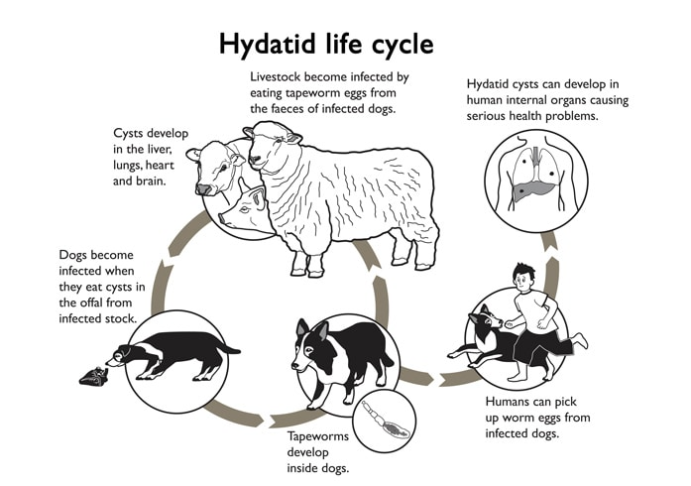

Hydatid Disease
Cause: The larval stage of the dog tapeworm Echinococcus granulosus.
Pattern of Disease: The adult tapeworm, which is about 6mm long, lives in the small intestine of infected dogs. The tapeworm eggs are passed in the dog’s faeces and spread out into the environment. These eggs are very strong and can survive for many months.
The life cycle continues when livestock, like sheep, eat the eggs. The eggs hatch into embryos that burrow through the intestine and enter the bloodstream. These embryos are carried to organs such as the liver or lungs, where they form hydatid cysts that grow slowly over time.
When dogs eat infected meat, the hydatid cysts turn into tapeworms inside the dog's intestines, completing the life cycle.
Disease in Humans: Humans can get infected if they accidentally swallow tapeworm eggs passed in dog faeces. The eggs are sticky and can stick to hands, clothing, children's toys, dog fur, or vegetables in the garden. Large cysts that develop in the liver, lungs, or other organs can cause serious illness and, sometimes, death.

How New Zealand Eradicated Hydatids
New Zealand successfully eradicated hydatids after nearly 50 years by having strict rules and practices which broke the life cycle of hydatids.
The rules and practices included:
- Do not feed dogs sheep or offal from livestock unless it has been treated. The meat should either be boiled for at least 30 minutes or frozen to -10°C or colder for at least 10 days to kill the parasite.
- Dispose of dead livestock quickly so dogs cannot get to them.
- Control dogs. Dogs should never be allowed to roam free, as even well-fed dogs will scavenge and could become infected.
- Home killing of sheep: If you kill sheep at home, make sure the area is dog-proof and bury the offal properly.
- Regularly dose rural dogs with a tapeworm treatment called praziquantel (Droncit) every six weeks. Urban dog owners who want to have their pets treated should contact a local vet.
- Practice good hygiene after handling dogs. Always wash your hands after touching them, their faeces, or anything they may have been in contact with.
These practices are still important to maintain to ensure the parasite doesn’t return. Rules about feeding offal to dogs and controlling dog behaviour help keep New Zealand free from hydatids and protect both animal and human health.

Exercise
- What is hydatids, and how does it affect dogs?
- How is hydatids different from sheep measles?
- How can humans become infected with hydatids?
- Why is hydatids considered a public health problem?
- How did New Zealand successfully eradicate hydatids?
- What rule was put in place about feeding offal to dogs, and why was it important?
- Why should farmers dispose of dead livestock quickly?
- What precautions should be taken if someone is home-killing sheep?
- How does regularly dosing rural dogs with praziquantel (Droncit) help prevent hydatids?
- Why do we need to keep following these practices even though hydatids have been eradicated in New Zealand?

Answers
- What is hydatids, and how does it affect dogs? Hydatids are the larval stage of the Echinococcus granulosus tapeworm. Dogs become infected when they eat offal (organ meat) from livestock that contains hydatid cysts. The tapeworm completes its life cycle in dogs, where it grows into an adult tapeworm in their intestines.
- How is hydatids different from sheep measles? Hydatids are a public health problem because they can cause serious illness and even death in humans. In contrast, sheep measles are not a health risk to humans but cause blemishes on sheep meat. Both diseases are caused by tapeworms, but hydatids affect humans and livestock more severely.
- How can humans become infected with hydatids? Humans can accidentally ingest tapeworm eggs from dog faeces. The eggs can stick to hands, clothing, children's toys, dog fur, or vegetables. If humans swallow these eggs, they can develop cysts in their organs, which can cause illness or even death.
- Why is hydatids considered a public health problem? Hydatids are a public health problem because the cysts they form in humans can cause serious health issues, such as cysts in the liver or lungs. These cysts can grow slowly and cause severe illness or even death if not treated.
- How did New Zealand successfully eradicate hydatids? New Zealand eradicated hydatids after nearly 50 years of effort, including strict rules about feeding offal to dogs, controlling dog movements, and regular dog worming. In 2002, New Zealand was declared "provisionally free" from hydatids by the Ministry for Primary Industries (MPI).
- What rule was put in place about feeding offal to dogs, and why was it important? The rule was that dogs should not be fed offal from livestock unless it had been treated by boiling for at least 30 minutes or freezing to -10°C or colder for at least 10 days. This was important because the treatment kills the hydatid parasite, preventing dogs from becoming infected and spreading the disease.
- Why should farmers dispose of dead livestock quickly? Farmers must dispose of dead livestock quickly to prevent dogs from scavenging and eating infected meat, which would allow the hydatid parasite to continue its life cycle and spread.
- What precautions should be taken if someone is home-killing sheep? If someone is home-killing sheep, they must make sure the area is dog-proof to prevent dogs from accessing the carcass. The offal must be properly buried to ensure dogs cannot eat it and become infected.
- How does regularly dosing rural dogs with praziquantel (Droncit) help prevent hydatids? Dosing rural dogs with praziquantel every six weeks helps to kill any tapeworms in their intestines, preventing the spread of hydatids. This is crucial for stopping the life cycle of the parasite and keeping the dog population safe from infection.
- Why do we need to keep following these practices even though hydatids have been eradicated in New Zealand? It’s important to continue these practices because hydatids could return if the preventive measures are not maintained. By keeping the rules and habits in place, New Zealand can remain free from hydatids and protect public health and livestock.

