# Facial Eczema in Sheep

In New Zealand facial eczema (FE) is one of the most important diseases of sheep, with annual losses that have been estimated to be over $120 million in some years. It occurs seasonally in the summer and autumn in most areas of the North Island and occasionally in northern areas of the South Island.

**Cause:**

* The disease is caused by a toxin (*Sporidesmin*) which irreversibly damages the liver.
* The toxin is produced by a fungus called *Pithomyces chartarum*.
* The fungus builds up in the dead organic matter of pastures in response to warm and moist conditions and produces spores which contain the toxin.
* When fungal spores are ingested, they release the toxin *Sporidesmin* which causes damage to the bile system of the liver. This, in turn, results in the accumulation of other toxins in the animal’s bloodstream, leading to poor health, low production, and potentially death.

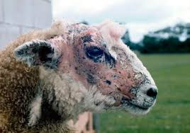

* An important secondary effect of the liver damage is called ‘photosensitisation’, visible as a severe and painful inflammation of unpigmented areas and exposed skin such as the udder, teats, ears and face (this is how the disease got its name). But it’s important to note that the disease is not always visible.

**Disease:**

The liver damage caused by the *Sporidesmin* toxin can lead to the following clinical signs:

**Clinical signs of Facial Eczema**

* Swollen drooping ears
* Restlessness, shaking of the head and ears or scratching of affected areas and seeking shade
* Peeling off, of the skin, particularly on exposed white areas
* Loss of weight
* Jaundice
* Death
* For every clinically affected animal there will be many more sub-clinically affected.
* Sub-clinically affected animals generally have reduced fertility and fecundity (ewes) or reduced growth rates (lambs). The affected ewes will often lose condition in late pregnancy and have higher death rates and poor lamb survivability.

**Treatment:**

Affected sheep should be given shade. One of the most effective methods is to keep affected sheep in the woolshed during the day (with covered windows, water and hay) and let them out to graze at night.

**Prevention and control**

* Monitor spore counts to identify safe and dangerous paddocks for grazing
* Use crops or supplementary feeds to avoid grazing high spore count pastures
* Sell lambs early before the risk period
* Spray pastures with fungicides to prevent further fungal growth for six weeks
* Dose stock with zinc to prevent or reduce liver damage
* Use zinc oxide intra- ruminal boluses
* 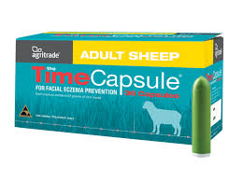Breed for FE resistance by buying FE tolerant rams.

***Exercise***

1. *Describe what causes of FE, include in your answer*

* *Causal agent*
* *Time of year*
* *Environmental conditions*

1. *Describe the visual signs of Facial eczema in sheep.*
2. *Explain how FE affects production in sheep?*
3. *There are several management practices farmers can use to prevent FE. One of these is the use of zinc. Describe the methods of how zinc can be used to protect sheep from FE and discuss advantages and disadvantages of each method.*
4. *The use of FE tolerant genetics is recommended as a preventive management practice in conjunction with other preventive management practices. Discuss why the use of FE tolerance genetics should be used and why genetics alone will not prevent FE in sheep.*