# Dyes From Plants

Colour has been important to people for thousands of years. For over 5,000 years, people have been dyeing their clothes with natural dyes from plants. These dyes were also used for face paint and war paint! Today, we use artificial dyes that can make colours that nature can’t, but many people are starting to rediscover how to use natural dyes again, especially those who enjoy spinning, weaving, and other crafts.

A **dye** is a special chemical (either natural or artificial) that adds colour to fabric. You can use almost all parts of plants—like flowers, berries, leaves, bark, and even roots—to make dyes! But not every plant works well for dyeing, so it’s a good idea to start with suggestions from your teacher. Once you get the hang of it, you can experiment more at home.

To dye wool, you’ll need to boil the wool with the plant material for a while, stirring to make sure the colour spreads evenly. Be careful, though! If you overdo it, you could turn the wool into felt.

A **mordant** is a special chemical that helps the fabric soak up the dye. Some plants, like walnut husks, don’t need a mordant, but most dyes do. Mordants also help make the dye last longer and can even change the colour of the wool!

Many plants from New Zealand make great dyes, so you’ll have plenty of options to explore.

### What You Need

* Two 250 ml beakers (or containers)
* A glass rod (for stirring), tongs, or tweezers
* White wool yarn (about 40 cm long), tied into small tassels (6 pieces with mordant and 6 without)
* Two small hanks of clean, raw wool (wash it first!)

### What to Do

1. Tear the plant material into small pieces until you have enough to fill both beakers about a quarter full (don’t pack it down too tight).
2. **Important!** If you’re using lichens or bark, crush them and soak them overnight.
3. Add hot water to each beaker until it reaches the 200ml mark.
4. Heat the beakers until the water boils.
5. Wet the wool and add it to the beakers, put the wool with mordant in one and the wool without mordant in the other.
6. Stir gently and let the water boil again. Keep boiling for at least 20 minutes, stirring occasionally.
7. Use tongs or tweezers to remove the wool (don’t use your fingers!) and rinse it in cold water until no more dye comes out.
8. Pat the wool dry with a paper towel to soak up most of the moisture, then leave it to dry on a clean paper towel overnight. If you're in a hurry, you can use a hair dryer to dry it quickly!

### Time Trials

Try dyeing wool yarn for three different amounts of time, like 5, 15, and 30 minutes. Take out one tassel at each time and follow steps 5-8. See how the colour changes with different times.

### Acid and Base Trials

Once all your dyeing is finished, you can try changing the colour by adding acid or base to the dye solution.

1. Split the leftover dye into two beakers.
2. Add a teaspoon of vinegar (or a few drops of hydrochloric acid) to one, and half a teaspoon of baking soda to the other.
3. Stir each solution until any bubbles settle down.
4. Put a piece of wool in each solution and heat for 5 minutes.
5. Take the wool out and rinse it, just like in steps 6 and 7.

Check to see how the colours change when you add acid or base!

### Natural Dyes

**Dyeing with New Zealand Native Plants**

1. **Kaka Beak**

Colour: Red

Kaka Beak produces a beautiful red dye, especially from the flowers.

1. **Harakeke (Flax)**

Colour: Yellow to brown

The leaves of the Harakeke plant can be used to create various shades, from yellow to brown, depending on the method.

1. **Totara**

Colour: Brown

The bark of the Totara tree can be used for a brown dye.

1. **Manuka**

Colour**:** Pink to red

Manuka flowers can provide a soft pink or red dye.

1. **Kauri**

Colour: Yellow-brown

Kauri bark can be used to create a yellow-brown dye.

1. **Cabbage Tree**

Colour: Yellow to golden-brown

The leaves can be used for dyeing fabric in shades of yellow to golden brown.

**Plants That Make Good Dyes:**

1. **Kumara (Sweet Potato**)

Colour: Orange

The skins of kumara can produce a warm orange dye.

1. **Carrot Tops**

Colour: Yellow to green

Carrot tops can be used to make a yellow or green dye, depending on the method.

1. **Dandelion**

Colour: Yellow

The flowers and roots of dandelions can create a bright yellow dye.

1. **Coriander Leaves**

Colour: Light green

The leaves of coriander can produce light green dyes.

1. **Spinach**

Colour: Green

Spinach leaves can be used to make a green dye.

1. **Onion Skins**

Colour: Yellow to orange

Onion skins, especially from red onions, can give a yellow to orange dye.

1. **Turmeric**

Colour: Bright yellow

Turmeric roots can produce a vibrant yellow dye and are easy to use.

1. **Avocado**

Colour: Pink to light red

The skins and pits of avocados create a pinkish dye.

### Artificial Dyes

Today, our world is full of bright colours, many of which come from synthetic (artificial) dyes. These dyes didn’t exist before chemists figured out how to create them in labs. Most artificial dyes already include a mordant, so they’re easy to use. You can even try out tie-dyeing with these synthetic dyes. Start with a piece of white cotton, like a handkerchief, before you tackle something bigger like a T-shirt!

### How to Tie-Dye: A Fun and Easy Guide

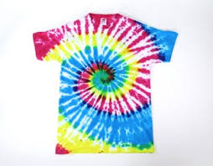

Tie-dyeing is a creative and colourful way to design your own unique patterns on fabric, such as t-shirts, bandanas, or even socks! Here’s a step-by-step guide to help you get started with tie-dyeing.

**What You’ll Need:**

* A white cotton item (like a t-shirt, socks, or a handkerchief)
* Fabric dye (you can use commercial tie-dye kits or make your own dye from natural sources)
* Rubber bands
* Plastic squeeze bottles (for applying dye)
* Plastic or plastic-covered surface (like a table or a plastic sheet)
* Plastic bags (for wrapping the dyed fabric)
* Plastic gloves (to protect your hands from the dye)
* Plastic squeeze bottles or spray bottles (for applying the dye)
* Plastic or plastic-covered surface (like a table or plastic sheets to work on)
* Water and mild detergent (for washing after dyeing)

**Step-by-Step Instructions:**

**1. Prepare Your Workspace**

Set up your dyeing area on a surface that is protected from dye stains, like a plastic tablecloth or plastic sheet. Wear old clothes or an apron and put on gloves to protect your hands.

**2. Pre-wash the Fabric**

Before you start, wash your cotton fabric to remove any dirt, oils, or chemicals that might affect the dye. Do not use fabric softener, as this can affect the dye’s ability to bond with the fabric. Let the fabric dry or leave it slightly damp for easier dye absorption.

**3. Decide on Your Tie-Dye Pattern**

There are lots of fun patterns you can create with tie-dye. Common ones:

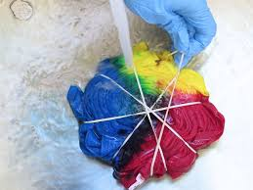

* **Spiral Pattern:** Pinch the fabric in the centre and twist it into a spiral.
* **Bullseye Pattern:** Start from the centre of the fabric and fold it into a fan shape, securing each section with rubber bands.
* **Crinkle Pattern:** Scrunch the fabric up randomly and secure it with rubber bands.

**4. Apply the Dye**

Now comes the fun part: dyeing your fabric!

Follow the instructions on your dye to mix it with water in squeeze bottles or spray bottles. If you're using natural dyes, you can make your own dye from plants but pre-made fabric dye is often easier for beginners.

* Apply the dye to different sections of your fabric, making sure to saturate each area. You can use one colour or multiple colours for a rainbow effect. Be creative with your colour choices!
* For a **spiral pattern**, alternate colours in sections of the spiral for a cool rainbow effect. For a **bullseye pattern**, use different colours in the different sections, creating circles of colour.

**5. Let the Dye Set**

Once the fabric is fully dyed, cover it with plastic wrap or place it in a plastic bag to keep the dye from drying out too quickly. Let it sit for 6–8 hours (or even overnight) for the dye to fully set. The longer you leave the dye on, the more vibrant the colours will be.

**6. Rinse and Wash**

* Once the dye has set, carefully remove the rubber bands and rinse the fabric in cold water to remove excess dye. You may want to rinse it separately to avoid dyeing other clothes by mistake.
* Once the water runs clear, wash the fabric in warm water with a mild detergent. You can machine wash it, but it’s a good idea to wash it separately from other clothing items to prevent any leftover dye from transferring.

**7. Dry and Enjoy**

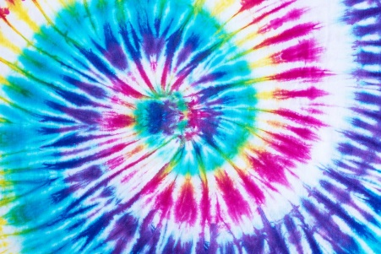Hang your fabric to dry or toss it in the dryer. Once dry, your unique tie-dye creation is ready to wear!

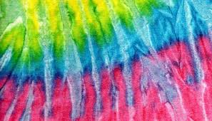

**Tips for Successful Tie-Dyeing:**

* Always use 100% cotton or other natural fibres like linen for the best results, as synthetic fabrics may not absorb the dye well.
* Be creative with your colour combinations! Try mixing different colours for a rainbow effect or use just one colour for a more subtle design.
* Use rubber bands to create different patterns, such as spiral, bullseye, or crinkle.
* If you're new to tie-dyeing, start with a small project like a handkerchief to practice before moving on to larger items like t-shirts.