**Dairy Farming in New Zealand**

**Location of Dairy Farms**

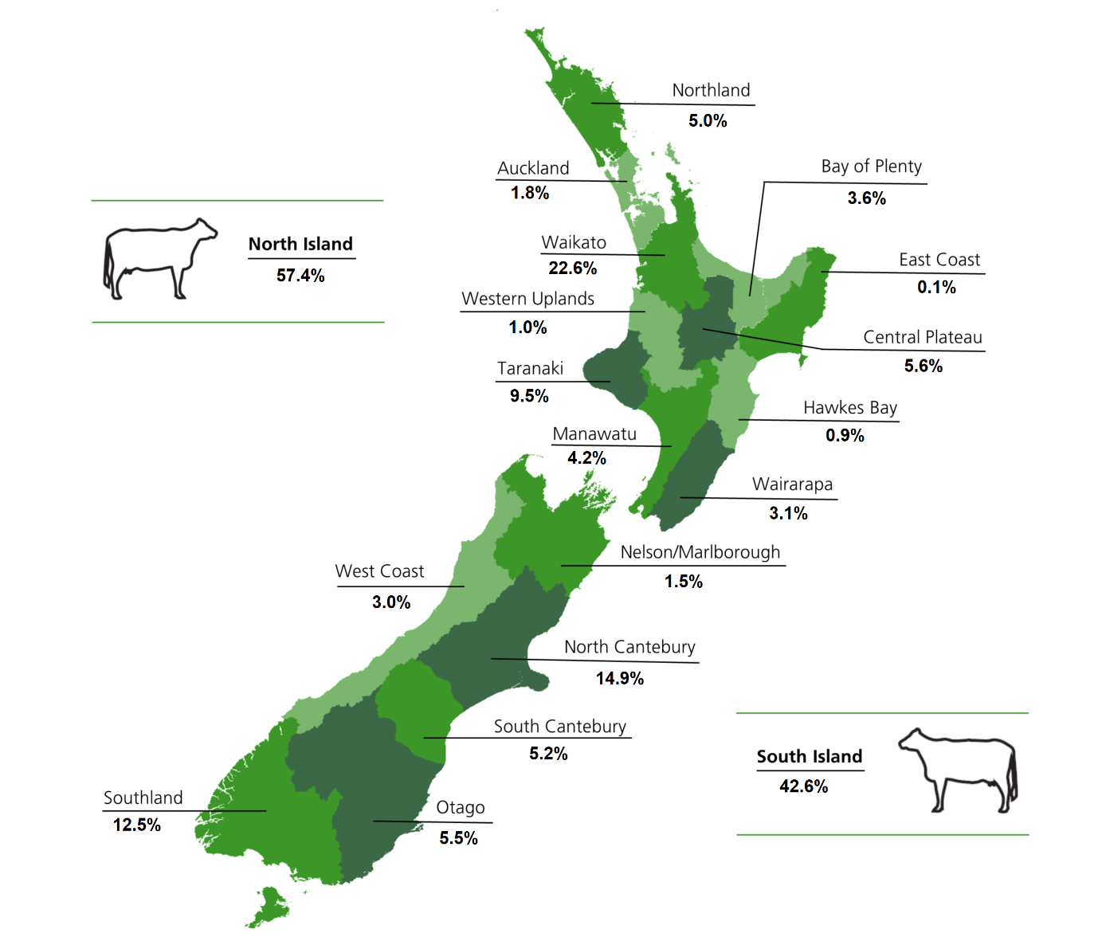

***Exercise***

1. *Name three regions which have a high percentage of dairy farms.*
2. *Explain why these regions have a high percentage of dairy farms.*
3. *Which Island has the highest number of dairy farms. Explain why?*
4. *Name two crops that are most likely to be grown on an intensive dairy farm and explain why.*

**New Zealand Dairy Overview**

Quick statistics 2023

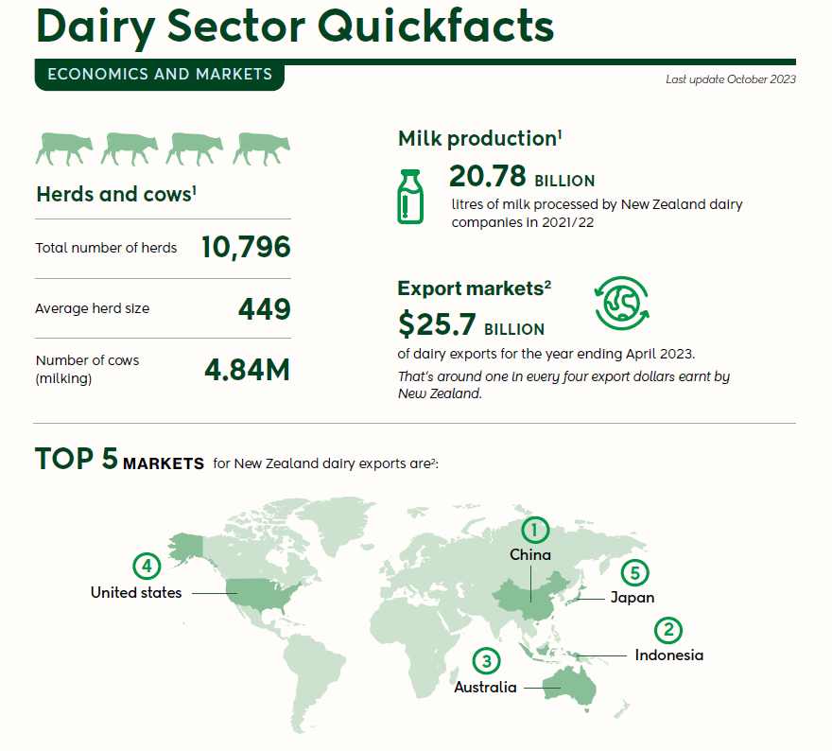

**Dairy Sector Fast facts:**

* New Zealand accounts for 3% of total world production
* New Zealand exports about 95% of its dairy production
* New Zealand is the world’s 8th largest dairy producer
* In the year to June 2023, dairy was New Zealand's largest export sector($23,775.0m), followed by meat and meat product manufacturing ($11049.9m) and fruit, oil, cereal and other food product manufacturing ($4423m).
* Dairy sector continues to grow its economic contribution, delivering $11.3 billion in value add to the economy in the year ending March 2023.
* The top five markets for New Zealand dairy exports are: China, Indonesia. Australia, Japan and United States.
* In the year to June 2023 New Zealand dairy exports were valued at approximately NZ$25.7 billion.
* The dairy sector employs over 50,000 people and generated $3.6 billion in wages in 2023.

***Exercise***

1. How many dairy farms are there in NZ?
2. What is the average size of a dairy her in 2023.
3. How much milk was produced from these dairy farms?
4. Where is this milk sold and how much income does it generate?
5. Which countries are the main market for NZ milk products?
6. Which region earns the most from dairy farms? Why is this?