Milking
When one or two cows are kept they can be milked by hand. Larger numbers are usually milked by machine.

Hand milking
Hand milking is difficult to learn from a book. It is much better to have a person showing you what to do. The main things to do are:
- allow the teat to fill with milk
- apply pressure by squeezing to bet this milk out of the teat.
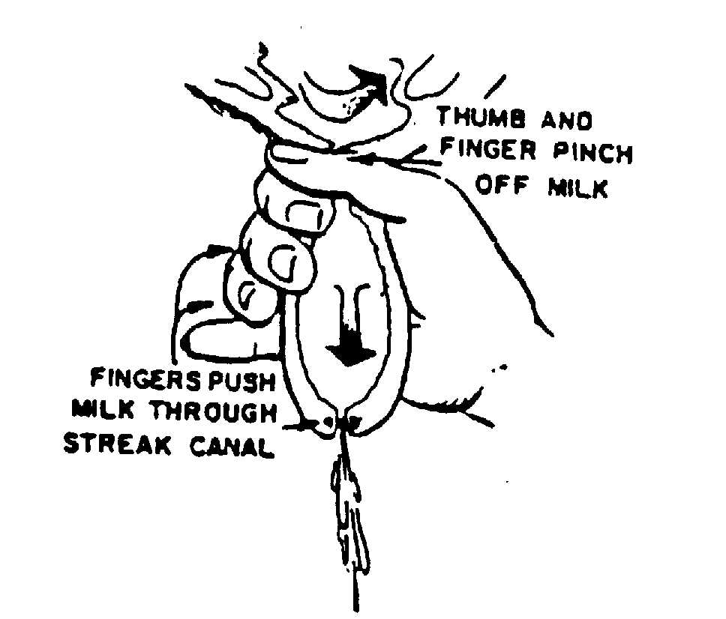
At the end of each teat is the streak canal that is closed by a band of muscle. The pressure of the hand must be strong enough to push the milk through the canal.

Here are other drawings showing how to milk by hand.
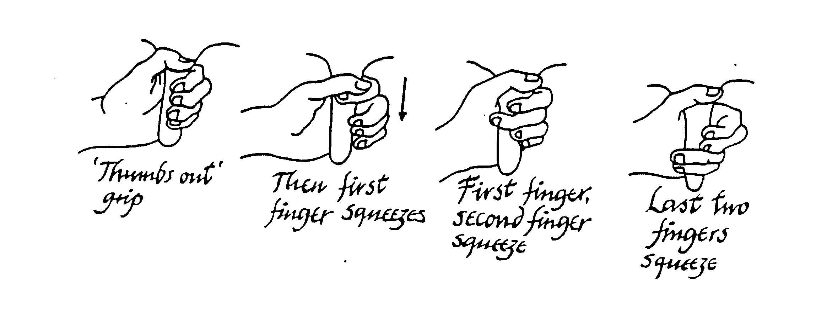

Machine milking
In hand milking the milk is squeezed out of the teats. In machine milking the milk is sucked out. The sucking is strong enough to overcome the force of the muscle and open the streak canal.
Each teat is put into a teat cup. A cow is supplied with a set of cups (4), an airline and a milk line (see diagram). All four teats are milked together.
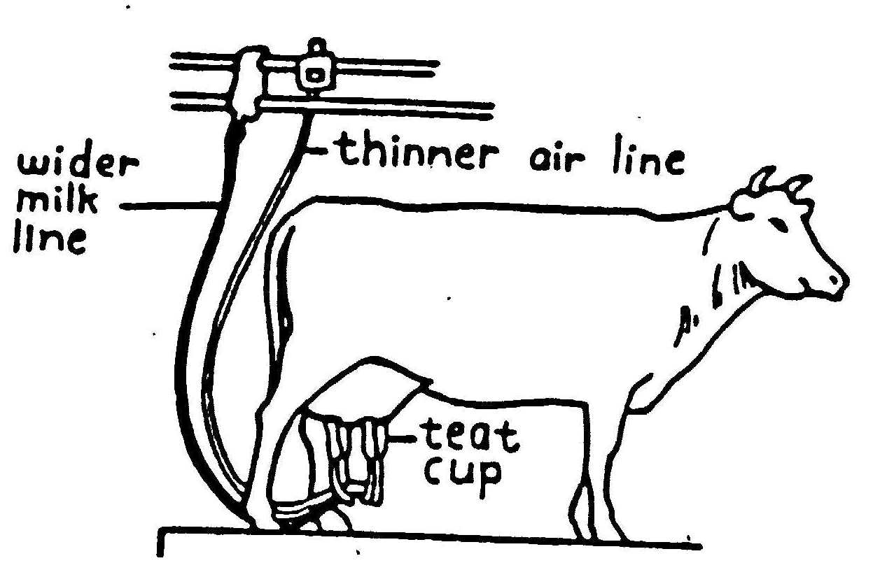

If milk was sucked out continuously the blood vessels in the teat would close off. This gets uncomfortable for the cow (like getting pins and needles or worse!) Teat cups are designed to give alternate sucking and resting. In the resting stage the teat fills with milk. The technical term for sucking is VACUUM.
