MAKING MILK
Cows make milk in their udders. To get the milk out, it has to be
“let down” into the teats.
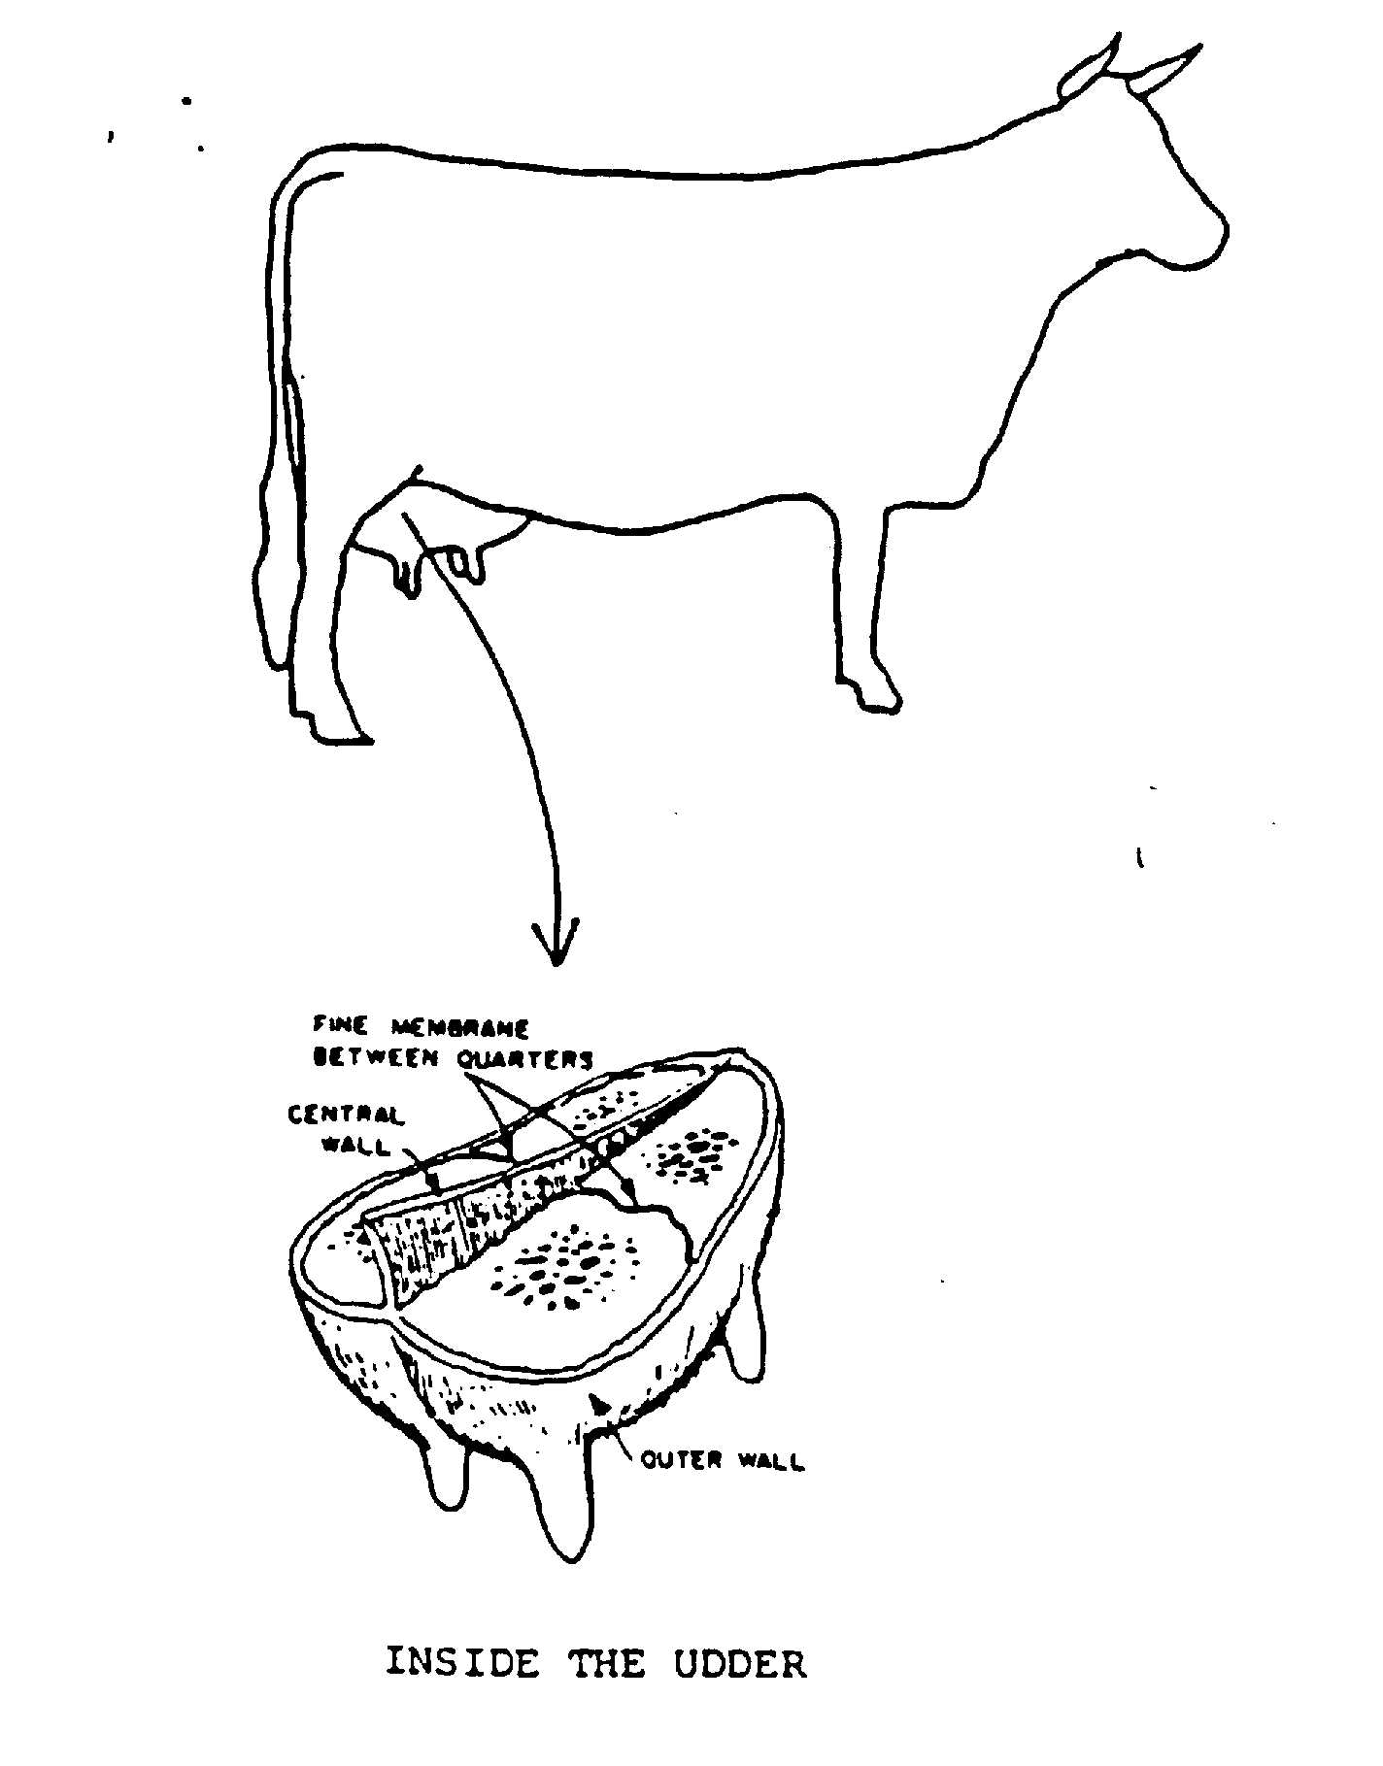

The udder

The udder is made up of four
separate parts or quarters.
Each quarter has a teat.

The right and left halves of
the udder is divided by a
strong wall. Very thin
membranes divide the
halves into quarters.

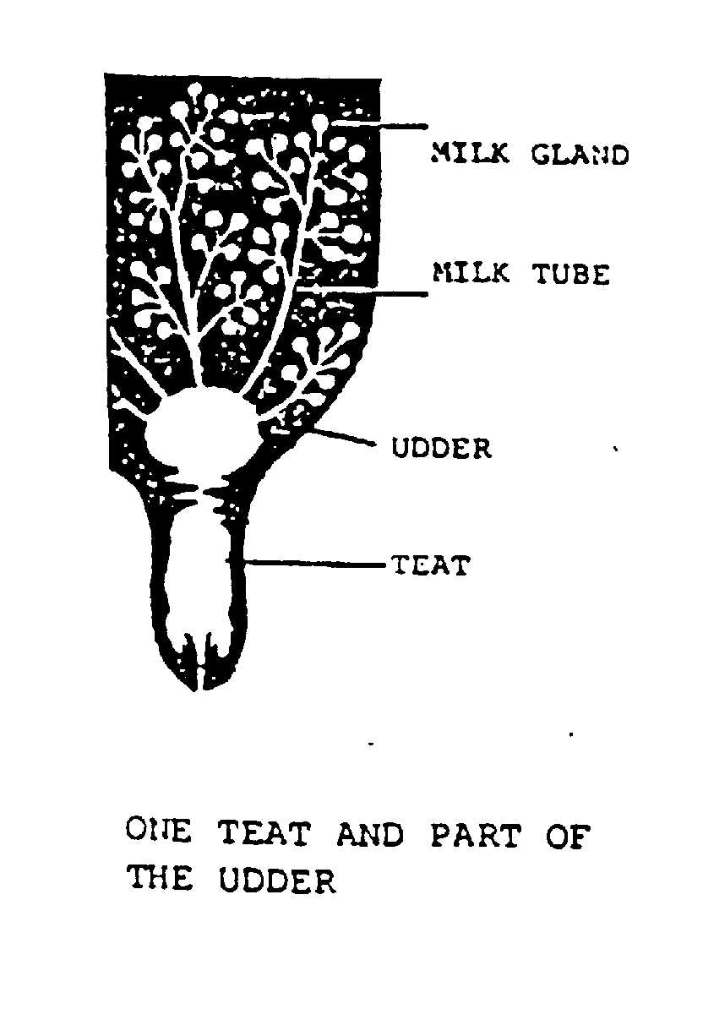
Each quarter is made up of thousands of tiny milk glands. The milk is made in these glands. The materials needed to make the milk are carried to the glands by the blood. The milk made in the tiny glands empties into fine tubes. These join to form larger tubes that meet in the lower part of the udder. During milking, milk from the tiny glands and the tubes passes out of the teat.

“LET DOWN”
Most milk is stored high up in the udder in the milk glands. It can only be “let down” to the teats by the cow.

HOW DOES “LET DOWN” OCCUR?
The skin of the udder, especially the teat tips, is sensitive to touch. When the mouth of a calf sucks the teats, nerves carry a message to the brain. This releases a hormone called OXYTOCIN.
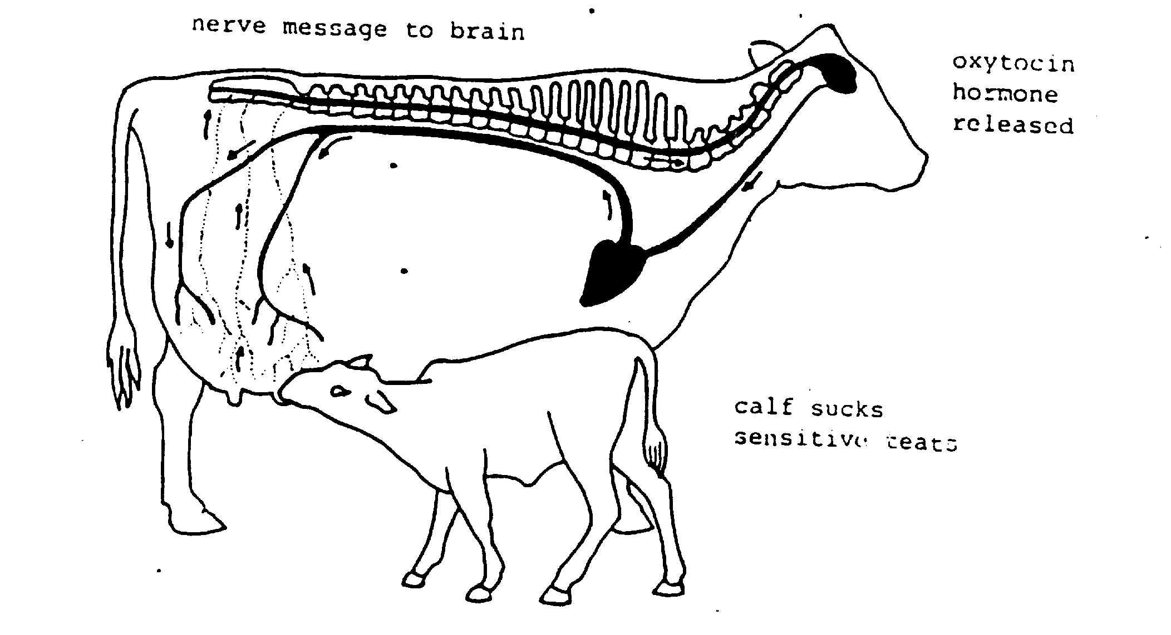

The hormone is carried by the blood system to the udder in less than a minute. Once in the udder the hormone causes the muscles round each milk gland to squeeze. This forces the milk into the tubes. The oxytocin hormone lasts for a short time in the blood, so milking must take place as soon as “let down” has occurred otherwise milk will be left in the milk glands.
A person washing the teats gives the cow the same feeling as a calf sucking, so the cow will “let down” milk. Many cows in modern dairy herds need very little touching of the teats. Just walking into the milking shed and hearing the milking machine going is enough to trigger the hormone to be released.

