HOW MILK IS MADE

- Digested food is carried by the blood into the udder.
- Here the blood vessels branch off into tiny capillaries. The food leaves the blood and enters the cells in the upper part of the udder. These are called the milk secreting cells or alveoli. (The blood continues through more capillaries and leaves by two milk veins.)
- The milk passes down through the milk ducts, from the milk secreting cells in the upper udder, into four milk chambers or cisterns, found in the four quarters of the udder.
- As milk is squeezed out through the teat canals more milk drains down into the cisterns from the upper udder.
- Forty litres of blood are needed to carry enough food to the udder to make one litre of milk.

Exercise

Ruby, a Kiwicross cow, produces 17 litres of milk a day.
- How many litres of milk do you use on average in your home each day, each week, each month and each year?
- How long would a day’s supply of Ruby’s milk keep your family going?
- How many litres of milk does your home use a year? If this milk was needed all at once, how many cows would be needed?

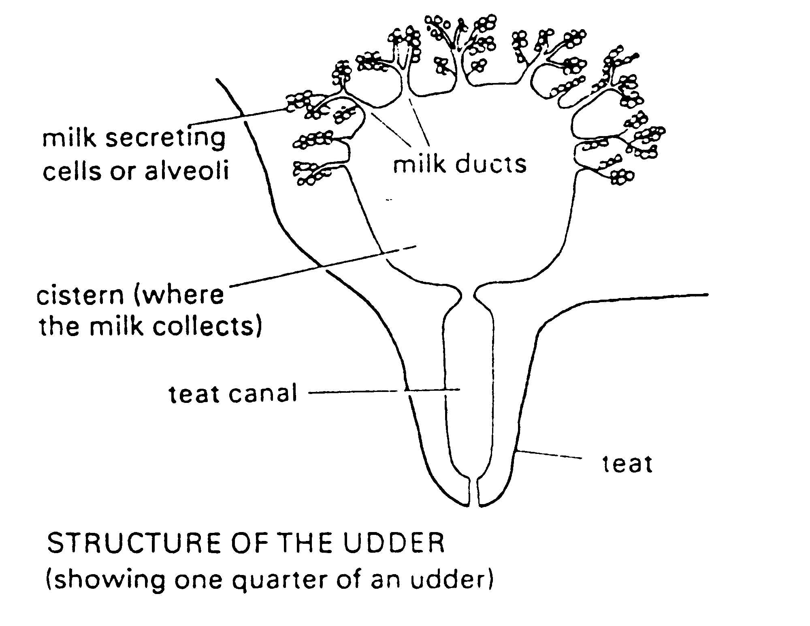

Use the words in the box to complete the sentences
teat, four, blood, milk, food, alveoli, quarters, one, upper

- Digested food is carried by the _____________into the udder.
- Here the blood vessels branch off into tiny capillaries. The__________ leaves the blood and enters the cells in the ________ part of the udder. These are called the ________ secreting cells or___________. The blood continues through more capillaries and leaves by two milk veins.
- The milk passes down through the milk ducts from the milk secreting cells in the upper udder, into __________milk chambers found in the four ____________ of the udder.
- As milk is squeezed out though the ________ canal more milk drains in to the chambers from the upper udder.40 litres of blood are needed to carry enough food to the udder to make ______ litre of milk.

