A DAY IN THE LIFE OF A COW

A cow’s day is divided into times when she is
- grazing
- chewing the cud
- being milked
- resting.

As we will see there is not much time for resting.

Grazing
Pasture contains a lot of water. To keeps cows healthy and producing a large amount of milk a lot of pasture has to be eaten otherwise cows do not get enough solid food.

Milking cows spend up to 12 hours a day eating (grazing) pasture. They spend more time eating than we do sleeping!

Grazing periods
If cows are not being milked the times they like to graze are:
- daybreak to 12 noon
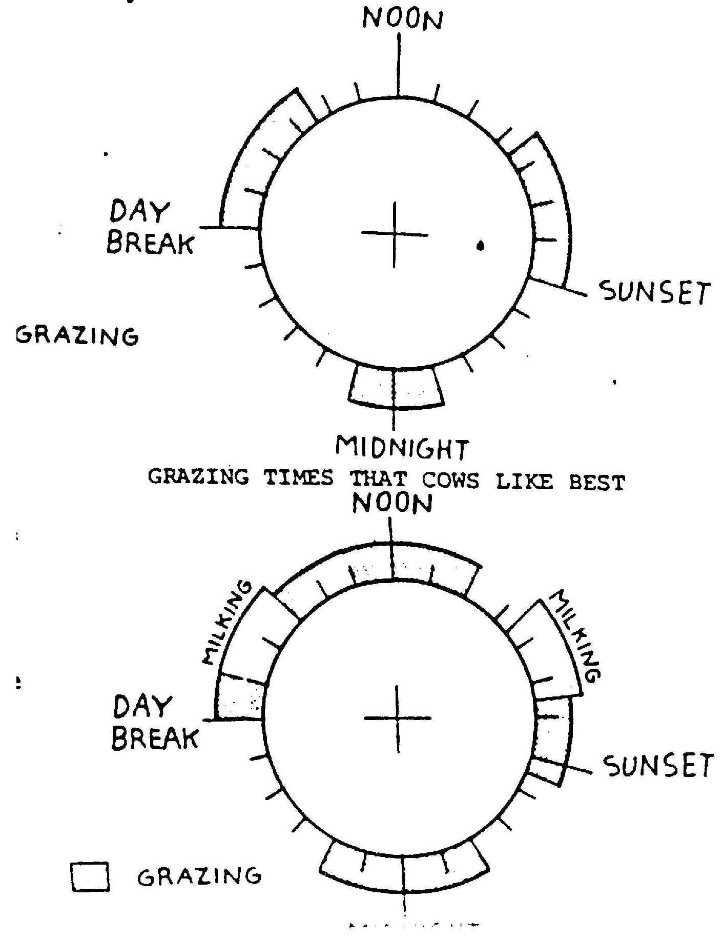
- mid-afternoon to sunset
- a shorter time around midnight.
Most cows are milked in the early morning and late afternoon. So milking interferes with the times cows prefer to graze. Milking cows have to change their grazing times. The diagram shows this.
Milking cows spend more time grazing during the night. This makes up for the loss in daytime grazing due to milking.

Chewing the cud

Cows have to spend a few hours each day “chewing the cud”. To do this cows bring up recently eaten grass called cud. Then they rechew the grass to make it finer and swallow it again. Cud is usually chewed lying down.
The grass is digested in the gut. Its nutrients pass into the blood and some are used to make milk.
digested carried
GRASS NUTRIENTS TO UDDER TO MAKE MILK
in gut by blood

Drinking
Cows drink a lot of water. Between periods of grazing cows drink water from troughs in the paddocks. Cows like to see each other while drinking at the trough otherwise a cow may get butted (shoved) by others in the herd.
Cows also like to drink water while they are in the yard waiting to be milked.

Resting
Most of the 24 hours of a cow’s day is taken up with eating, chewing the cud and milking. It is a good thing that cows sleep very little! Any spare time is spent resting.

Questions
- How many hours a day does a cow spend grazing pasture?
- What is meant by chewing the cud?
- How do nutrients get to the udder to make milk?

