Calendar of Work on a Typical North Island Dairy Farm
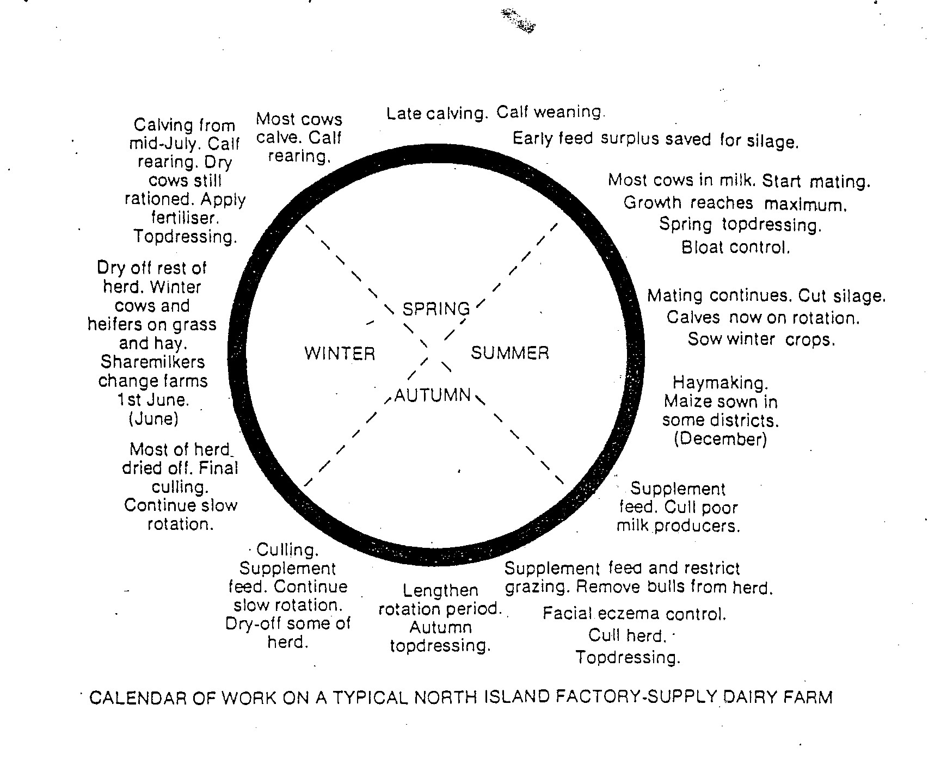

Exercise
1. What is meant by “calf weaning”?
2. When do the cows start to calve on this type of dairy farm and explain why?
3. What is meant by “drying off and when does “drying off” occur on this farm?
4. What is meant by a “cull cow”?
5. Explain three reasons why a farmer would cull a cow?
6. What is meant by “supplementary feeding” and name two common supplementary feeds used on a dairy farm?
7. Describe what is silage and explain when and why silage is made?
8. When would a farmer feed silage to cows and why?
9. Hay is made in summer. When would a dairy farmer feed out hay to cows and why?
10. Explain what bloat is and what causes it?
11. “Facial eczema” is a disease caused by fungi. At what time of the year is this disease a problem and how does it affect milk production?
12 Explain why most dairy farmers used AI?
13. 95% of NZ dairy farmers herd test. What is herd testing and how do farmers use the information gathered from herd testing?
14. If a farmer had 30 paddocks how do they
- shorten the grazing rotation?
- lengthen the grazing rotation?
15. Explain how farmers apply nitrogen fertiliser and explain when and why it is applied.

