**Artificial Insemination (AI) = Artificial Breeding (AB)**

AI (artificial insemination), also known as AB (artificial breeding), is the physical placement of semen into the reproductive tract of females with the aim of achieving pregnancies by means other than that of natural mating.

**Advantages of AI are:**

* Superior genetic at an affordable cost (Genetically superior sires that have been proven can be used (the average farmer could not afford to buy these bulls)
* More cows and be breed to one bull.
  + through natural breeding one bull can be breed to 20-50 cows in a breeding season
  + through AI, thousands of cows can be breed to one bull in a breeding season. The desirable characteristics of a bull or other male livestock animal can be passed on more quickly and to more progeny than if that animal is mated with females in a natural fashion.
* With good heat detection conception rates with AI are just as reliable as natural mating
* Specific cows can be bred to specific bulls to improve the genetic performance of the herd
* No risk for transmitting of reproductive diseases.
* Reduces concerns of death/injury to high value bulls or to cows
* Improved herd genetics and production
* Protection against infertile bulls
* Sexed semen can be used (90% chance of heifer calf)
* Semen can be imported from bulls overseas.

**Disadvantages of AI are:**

* Accurate heat detection and the correct timing of insemination are critical for conception.
* Requires well trained technicians that understand the structure and function of the reproductive system and specialised equipment
* Requires more time than natural mating
* Improper cleaning of instruments and poor hygiene may lead to lower fertility
* If the bull is not properly tested poor traits or hereditary diseases can be passed on.

***Exercise***

1. *Why to nearly 100% of dairy farmers use artificial insemination for at least the first 4-6 weeks of mating.*
2. *Explain how the disadvantages of using AI can be overcome*

# A.I MATING CHART

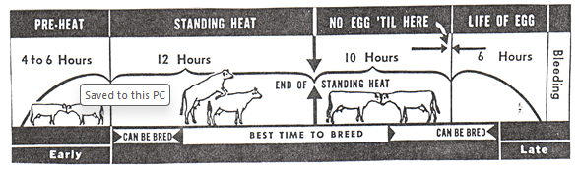

*Use the A.I MATING CHART to help you answer the questions.*

1. *Describe* ***two*** *ways a farmer could tell if his cows were coming on heat?*
2. *If a farmer was sure that a cow was on heat, how many hours would he have in which to have her artificially inseminated?*
3. *What is meant by “****standing heat****”?*
4. *How long would it be before the cow came into heat again if she did not get in-calf after the first insemination?*
5. *If a cow does not get in-calf after the first insemination, what would be the economic consequences to the farmer?*
6. *If a farmer wished to keep a calf from a high producing cow, how*
7. *would the farmer identify the calf?*
8. *would he know which cow the calf was from?*
9. *List three things that “****herd****-****testing****” tests for.*
10. *Explain the benefits of herd testing to the farmer.*
11. *Explain how milk productivity in dairy cows is recorded?*
12. *List* ***two*** *advantages of artificial insemination.*
13. *Discuss how the use of AI improves farm productivity.*