**Digestion Cross Word Puzzle**

Complete the crossword puzzle below

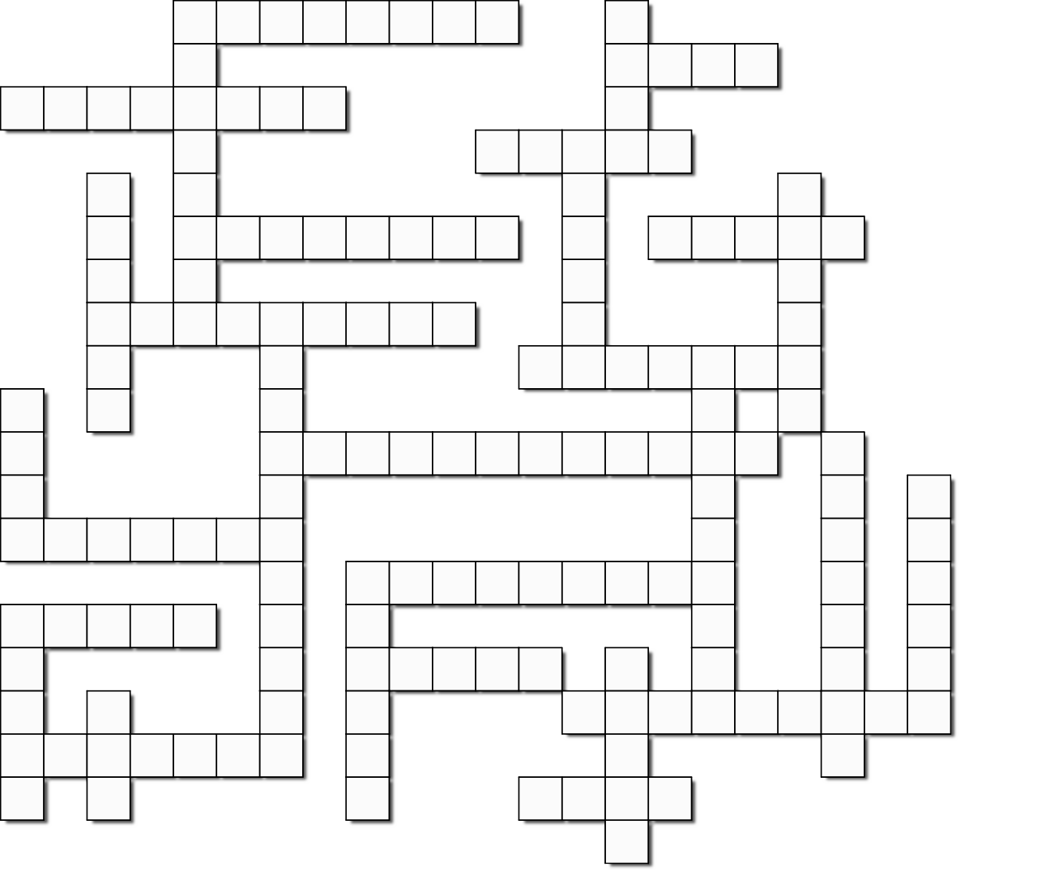

1

2

3

4

5

6

7

8

9

10

11

12

13

14

15

16

17

18

19

20

21

22

23

24

25

26

27

# Across

**1.** Another name for fibre in foods is -----.

1. A mineral needed to prevent anemia
2. These substances are needed in very minute amounts to maintain health.
3. Faeces are another form of from the body.
4. Chemical digestion in ruminants occurs in the --.
5. Liquid water removed by the body
6. The has a honeycomb lining.

**13.** A mineral needed for strong teeth and bones

**16.** The name for sugar, starch and cellulose

1. Needed for bodybuilding and growth.
2. Pasture and turnips are examples of feeds.
3. The organ that produces bile
4. The building blocks of proteins are acids.
5. The process that breaks food down.
6. It is a simple sugar
7. A liquid produced by the liver

# Down

1. Sheep and cattle are collectively called----
2. All animals require a balanced---
3. Helps neutralise the contents of the rumen
4. The role of volatile fatty acids
5. The substance responsible for the chemical breakdown of foods
6. Palm kernel is an example of a
7. Most absorption of the products of digestion occurs int the small --
8. The organ the food enters immediately after a hen swallows it.
9. Microbial digestion is carried out by protozoa, fungi and ---
10. Nutrients are mostly made up of , hydrogen

and oxygen.

1. Grains and potatoes are rich in it
2. In the intestine water is removed from the

food material.

1. The omasum is often called the --.
2. Another name for rumination is chewing the –

Answers



4 v

i

t a

1 r u m i n 9 a n

t

o u g h a g e

i

n

s

5 w

a

b

o

m

a

s

u

m

6 s a l i v

a

2 d

3 i

e t

r o n

e

7 e n e

11r

g y

10u

r

i

e

i

12c

o n

16c

e n t r a t e

u

l

u

m

13c

l

c

a

r

b

o

h

y

d

r

a

14i

n t e s t i n e

u

15c

r o

19p

8 e

n e

z y m e

e

r

o

t

e

i

20s

t

22a

r c h

u

c

c

u

l

e

n

21l

a r

26g

e

i

v

e

r

m

i

n

o

24c

u d

25d

23b

i b l e

g

s

t

17b

a c t e r i a

18c

a r b o

o n

l

c

o

s

27b

i

e