Beef Farming Systems
The most common way of beef farming in this country is to breed the young stock on one type of farm. They are then sold some time after weaning (called weaners) to another farm. They are sold either directly to the second farm or through saleyards. The second farm provides good grazing so that the animals grow rapidly. This is called finishing. Cattle should reach a suitable weight for slaughter at about 20 months.

Beef breeding
Beef is bred on two types of farms. These are dairy farms and hill country farms.

DAIRY FARMS
These produce bull calves and surplus heifers for beef. The weaners are sold at 100kg at about 10-12 weeks.

HILL COUNTRY FARMS
The beef herd of breeding cows and bulls produce beef calves. Some are sold as weaners at
8 months and the rest as yearlings at 12 months.

Beef finishing
Beef finishing farms provide good grazing for beef animals to grow rapidly. A few beef farmers on good easy land breed and finish their beef cattle on the same farm. These are beef farms.
The diagram shows the different kinds of beef farming systems.
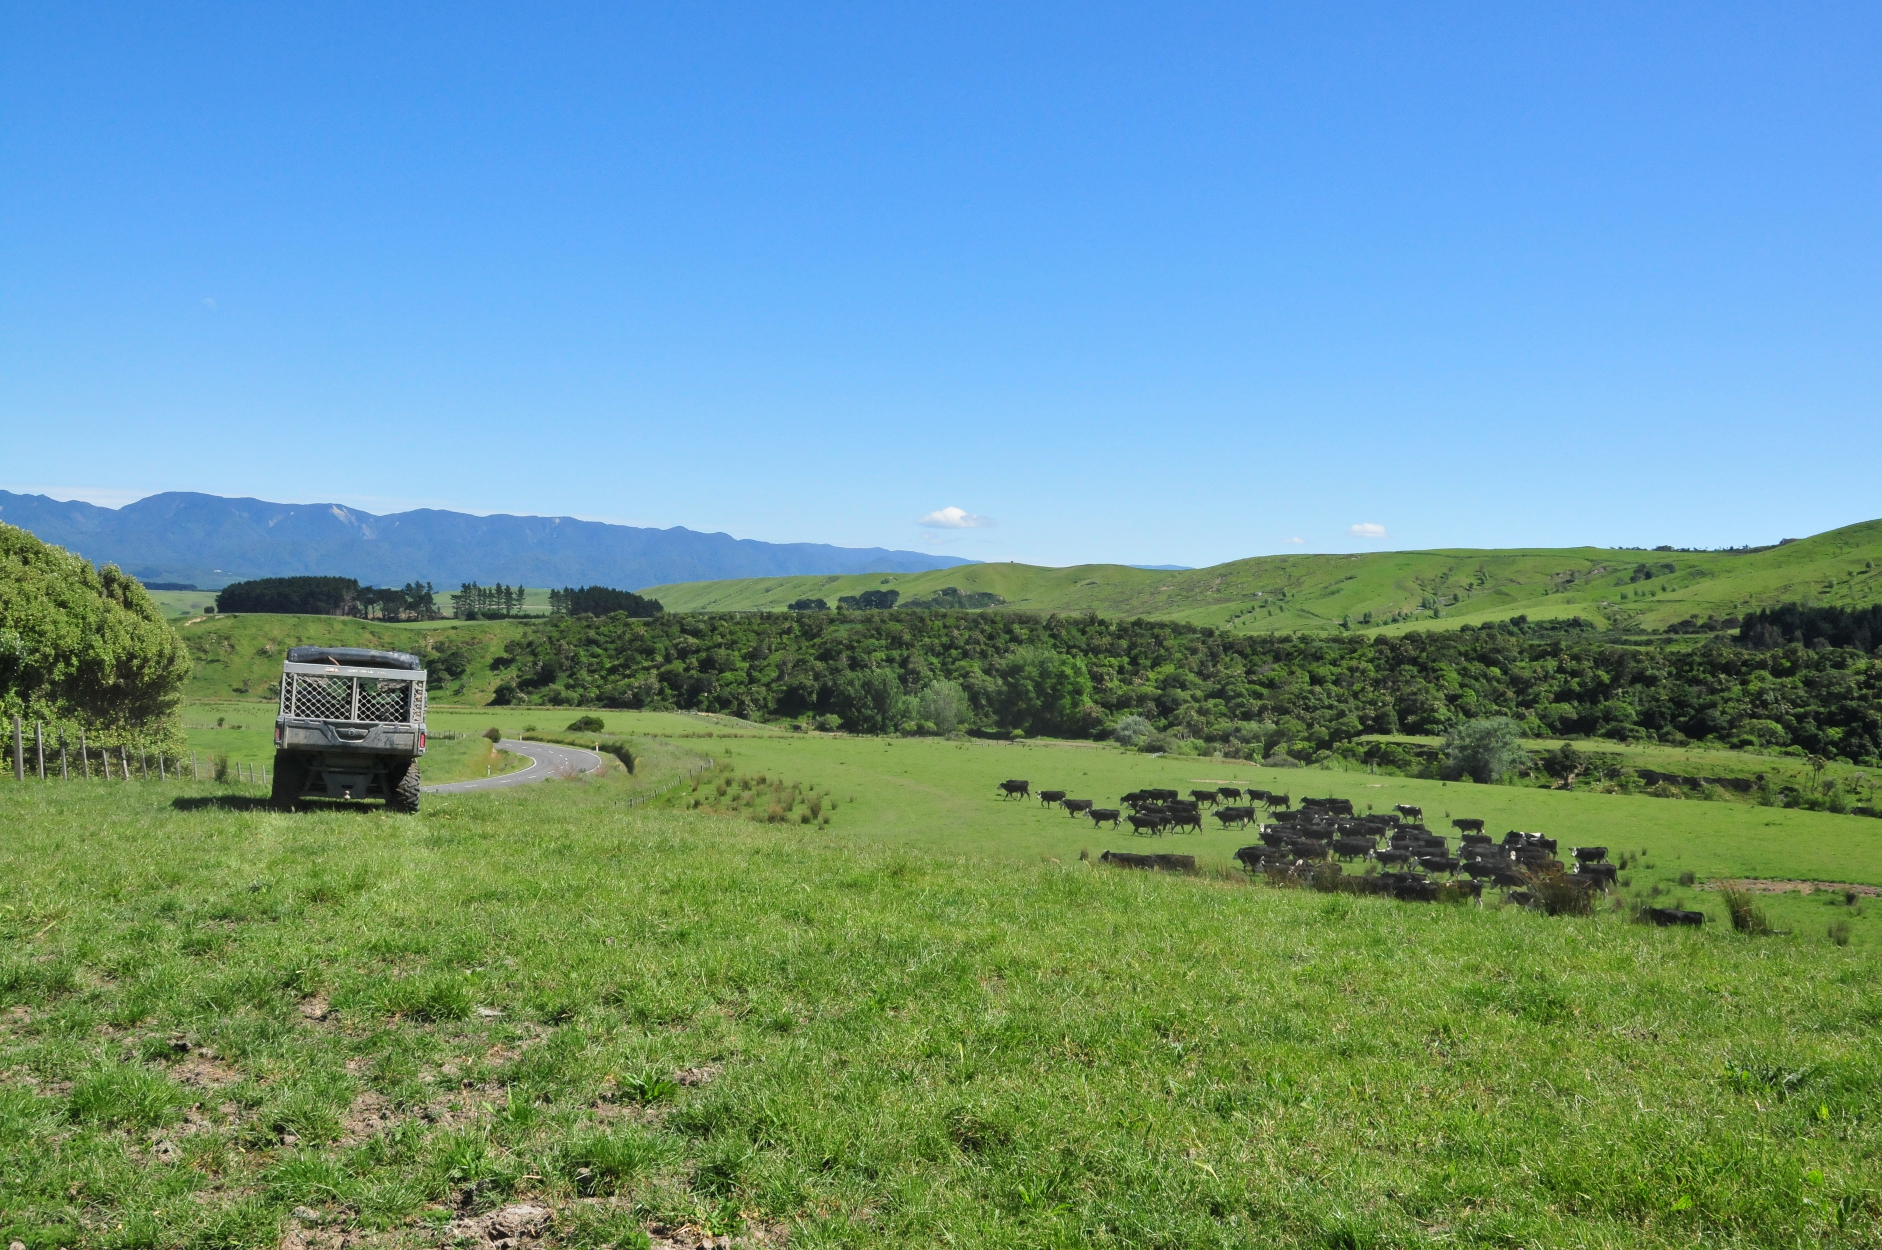

DAIRY FARMS
produce
WEANERS

HILL COUNTRY FARMS
produce
WEANERS and YEARLINGS

WEANERS
(3-6 months)

YEARLINGS
(12 months)

sold via
SALEYARDS

sold directly to
FINISHING FARMS

FREEZING WORKS
(mainly export beef)
and
ABATTOIRS
(with fresh beef meat)

sold at
20 months to

BEEF FARMS
These are on easy land. A beef herd is kept for breeding. The young beef animals are grown to slaughter on the same farm.

Exercise
- Why do you think beef calves are sold to a finishing farm?
- Explain the two ways they get to this farm.
- At what age are most beef animals ready for slaughter?
- Beef calves can also come off dairy farms. What is the name given to these beef animals?
- At what age are calves weaned on dairy farms or by calf rearers sold?
- At what age are calves reared on hill country farms sold?
- Explain the differences between freezing works and abattoirs.
Beef cattle on hill country farms
The beef cattle on hill country farms have two purposes:
- one is to breed beef calves
- the other is to keep pasture in good order.

How do they keep pasture in good order? They do this in three ways.
- Grazing pasture evenly
Use sheep to ensure pasture is grazed evenly. Sheep are rather fussy eaters. They leave the pasture plants they don’t like. These grow long and stalky. Cattle are not so fussy and will graze the pasture more evenly. Cattle are put into paddocks when the sheep are moved on. They can also graze in the same paddock with the sheep.

- Preventing erosion
Erosion is removing soil from the land. Sheep cause more erosion than cattle because they graze close to the ground. Close grazing exposes soil. Rainwater running down steep hills will carry away soil. Slips and gullies also develop. However, eroded land recovers if sheep are replaced by cattle for a few years. Cattle graze less closely and so the grass grows longer. It protects the soil. Cattle (unlike sheep) stay off slips. This allows seeds on slips to grow into plants that cover the ground and protect the soil.

- Controlling scrub
A large number of heavy cattle, over two years of age, are sometimes kept on hill country farms. They prevent pasture being taken over by scrub and fern. Their weight tramples these large scrub plants down. They also eat fern. When sold these cattle won’t fetch the best prices but they’ve done an important job on the farm keeping scrub under control.

Exercise
- Describe the two purposes of beef cattle on hill country.
- Describe the three ways they keep pasture in good order.
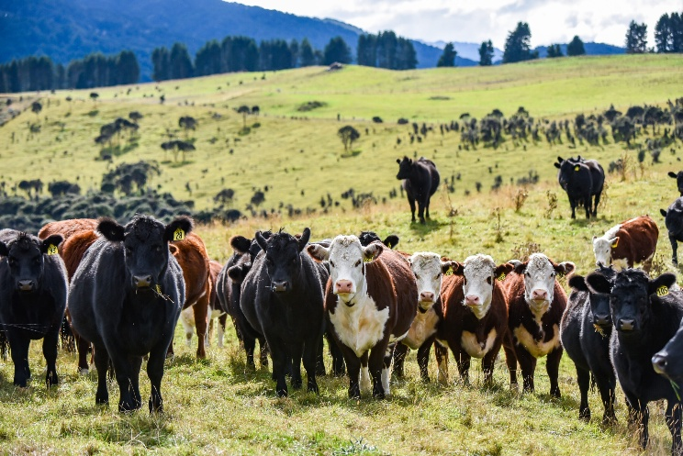

Dairy Beef
Dairy farms produce many extra calves, including all the bull calves and surplus heifer calves (those not needed to replace older dairy cows). In the past, most of these calves were slaughtered when only a few days old (called bobby calves). Now, many of the extra calves are either kept on the dairy farm until they are weaned or sold to calf rearers to be raised to weaning age. Most are then sold and raised by beef farmers. About 70% of the Friesian-type cattle on beef-raising farms come from dairy farms. The rearing of animals from dairy farms for beef is commonly called dairy beef farming. Dairy beef is a flexible farming system, with extra calves available each year.
Friesian Bull Beef
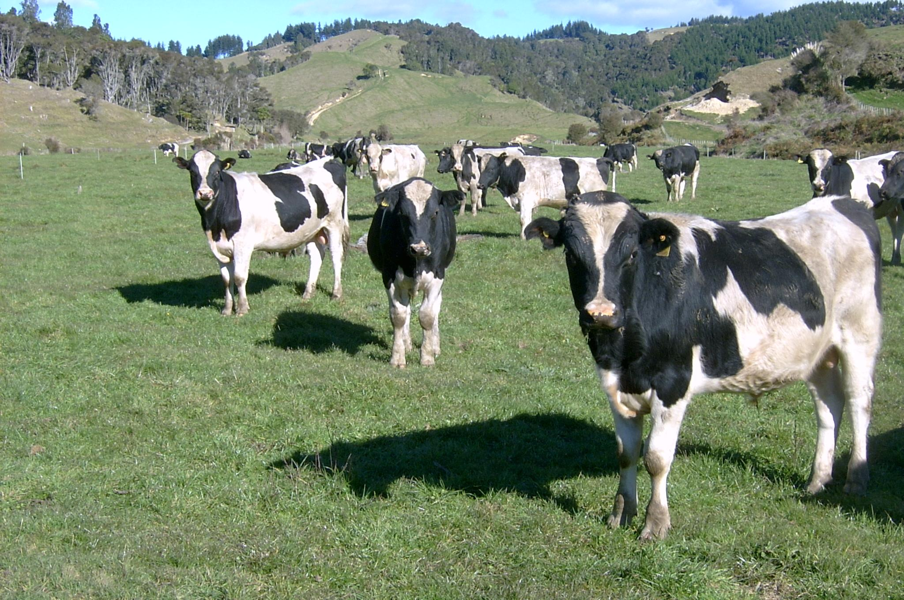

The Friesian is the main breed used in dairy beef. Pure Jersey animals have fat that is too yellow to be acceptable for the beef trade. However, when Jersey cows are crossed with beef bulls the fat is paler and acceptable. These crossbred offspring have a good growth rate and tender meat.

Dairy cows x beef bulls
Many dairy farmers are using semen from high-producing beef bulls or good beef bulls over lower-producing cows or late-calving cows to improve the characteristics of dairy beef calves, in order to minimize wastage of surplus calves and reduce the number of bobby calves.

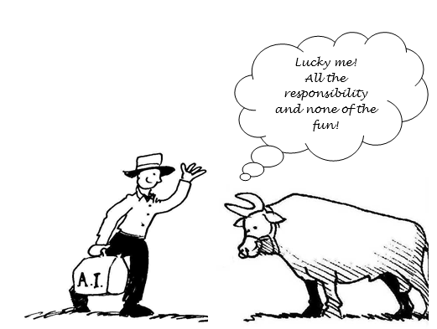

Exercise
- Describe 2 farming systems by which Friesians are reared for beef.
- The following 7 statements belong to either Friesian beef or dairy beef. Put them into the correct column of the table below.
- bull calves and surplus heifers reared to weaning then sold.
- Friesian and Friesian-cross cows on beef producing farms
- Good foragers.
- A flexible beef rearing system depending on prices.
- Mate only lower milk producing cows with beef bulls.
- A source of extra income (most income from milk sales).
- Usually mated to a beef breed bull, such as Angus.
Friesian Beef | Dairy Beef

- Why do Friesian cows make good mothers?
- Why is the young Friesian a successful beef animal?
- Why are pure Jersey animals not ideal for the beef trade?
- What is the purpose of crossing Jersey cows with beef bulls?
- How do dairy farmers try to reduce the number of bobby calves?

