# Potatoes



FACT SHEET

18

Potatoes are a must-have vegetable in the garden. They’re a tasty and versatile addition to any meal. And not much beats home-grown potatoes at Christmas lunch or dinner.

## Where to start

For disease free spuds, always buy and plant certified ‘seed’ potatoes, rather than any regular shooting potato. Seed potatoes are certified disease-free tubers which look like regular potatoes but are usually a little smaller.

## Choosing a variety

Choose the type of potato based on when you want to harvest and then what you want to do with it. Check out the range shown and their features to help you decide.

## Early Varieties

Potatoes vary in their make up. Some are called ‘waxy’ potatoes, and these are lower in starch and hold together much better when cooking - they are more suitable for salads and boiling, the classic ‘new potatoes’. Other varieties are called ‘floury’ potatoes, and these are higher in starch and ideal for wedges, chips, roasting and mashing. The earlier potatoes tend to be more the waxy types, and the later varieties more floury.”

NZ Bulbs has 12 different varieties of seed potatoes available including well known varieties like Jersey Benne, Agria and Rua.

For a general-purpose potato, try Desiree or Rua. If you want to serve home-grown spuds at Christmas plant the early varieties. These can be harvested after about 90 days so, if planted in September, will be ready for Christmas.

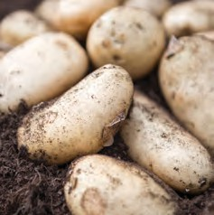 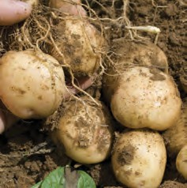 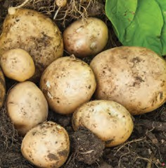 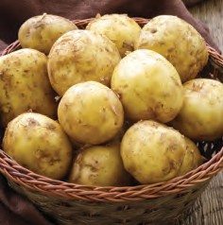

Cliﬀ Kidney Waxy, 80-90 days

Jersey Benne Waxy, 80-90 days

Rocket Waxy, 60-70 days

Swift Waxy, 60-70 days

## Early - Main varieties

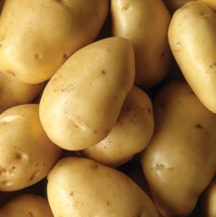 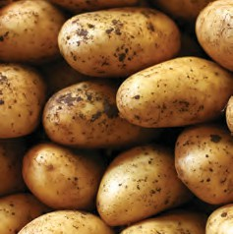 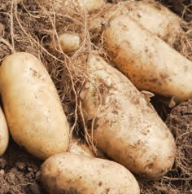 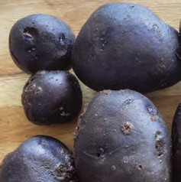

Heather Waxy, 80-90 days

Ilam Hardy Floury, 70-80 days

Nadine Waxy, 80-90 days

Purple Passion

All-purpose, 70-80 days

# Potatoes ~ continued

## Main Crop varieties

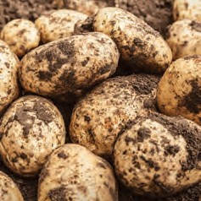 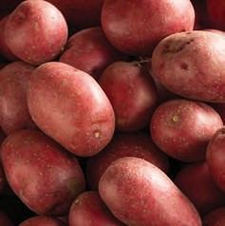 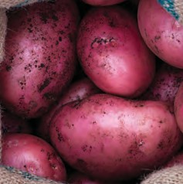 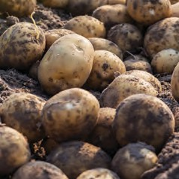

Agria Floury, 90-100 days

Desiree

All purpose, 90-100 days

Red Rascal Floury, 90-100 days

Rua

All purpose, 100 days

## Preparation

Once purchased, remove the seed potatoes from the bag or container and leave them in a light, dry place to sprout for a few weeks – somewhere like a garage bench or garden shed is ideal.

When the shoots are around 2cm long they’re ready to plant. Before doing so, add some compost to the soil and mix well. A well composted garden will give you better results come harvest time as it makes the soil more friable and easier to work.

## Planting

Dig a trench about 15cm deep and place the potatoes in the bottom of it - approximately 40cm apart. Don’t fill the trench back up, just cover the planted potatoes with at least 5cm of soil. New spuds hate Jack Frost, so keep an eye on them and as the shoots start to push through, cover them a little more each week until the trench has been turned into a mound of 15-20cm in height. The more growing stem beneath the soil, the more opportunity for the plant to produce potatoes and the bigger the crop.

Once planted cover the crop with some insect- proof netting which will keep out the potato- tomato psyllid, a small insect that can cause a lot of damage to tomato and potato crops. The netting is a perfect non-spray method to ensure the potatoes stay healthy and yield a great crop.

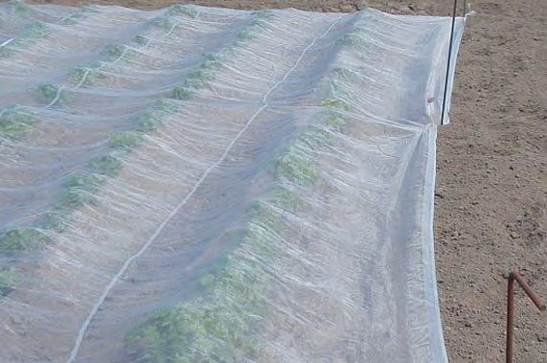

Make sure the netting is tucked into the soil all around the edges and keep it loose so the potatoes can easily grow up beneath.

Because the plants can be attacked by the psyllid at any growth stage, put the netting on the potatoes once planted and keep it on until harvest. Put the netting on loosely at the start or loosen it as they get bigger. Make sure the plants aren’t pushing hard against it or being damaged and that it is tucked into the dirt securely on all edges.

## Care while growing

Once a month mound the soil around the potato plant. Ensure 5cm of the plant’s stem is left sticking out the top. To keep diseases away don’t overhead water the potatoes excessively. Once planted the rain should be enough to keep them going until they’re ready for harvesting.

## Harvest

The best way to tell if the potatoes are ready is to dig a few up to check. Use a fork and loosen the dirt around a few of the potato plants, gently pull out a spud ensuring the shoot connecting it to the plant doesn’t get broken. If the potatoes are small, cover them up again with dirt and leave to mature further.

## Post harvest

Once the potatoes are harvested dig the remainder of the plant back into the ground. The top growth has plenty of good nutrients in it and working it into the soil helps to improve the soil structure in the same way that adding compost does.

