FIGHTING TO SURVIVE
Your task: - is to decide how your village is
going to survive
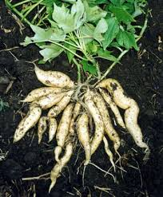

Kumara

Kumara, yam, taro, hue, and tropical
cabbage tree is all you have to grow
in New Zealand, but they may not
grow in your area!!!!

Kumara-needs shelter, sunny, well drained
places.

Taro: - needs flat, damp, river silt to grow in

Hue (gourd): - need fertile, moist warm
places.

Cabbage Tree and Yams: - only grow in hot humid places (there are native cabbage trees through)

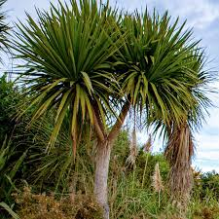

Cabbage tree
Remember you need a balanced diet

Decide

All the things you are going to use for food, and how you are going to catch those that are wild.
- How you are going to cook and store all this food.
- What are you going to make clothes out of?
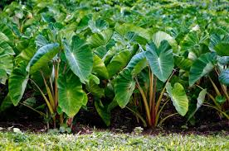
What you are marked on

Write- up

- On the large blank sheet of paper draw a map of your land.
Use symbols to show all the things you are going to grow.

On ordinary paper write a summary explaining how your
village is going to get everything they need.
(Remember how to catch those things that are wild).
- Present your survival plan to the rest of the class. Taro

Group A

Your Land
1 You live beside a large river which has a narrow band of flat silt land either side of it, growing manuka and bracken fern.
- Either side of the river are hills covered in forest.
- There is a small area of flax growing at a bend of the river.
- On one of the streams flowing into the river, greenstone occurs.
- Cold climate but sheltered.

Group B

Your Land
- You live beside a lake.
- Lots of flax, raupo and toetoe grow around the lake on one side, where two streams flow into it.
- On the other side is a large area of flat silt land, where a river flows out of the lake
- Surrounding the lake on three sides are forest covered hills.
- Following the river for five days gets you to the sea, a small bay in a rocky coastline.
- Moderate, wet climate, and windy around the lake.

Group C

Your Land
- You live beside the sea.
- There is a river flowing into the sea, which has formed a large flat, flood plain over the years.
- On one side of the river is an area of flax, raupo and toetoe.
- The other side of the flood plain is hills covered with bracken fern, manuka and pockets of forest as you move further back.
- Moderate climate, not noted for high temperature and humidity but windy

Māori Horticulture
Polynesian people migrated and colonised lots of islands in the Pacific, including New Zealand. From their original homeland they took lots of animals and plants to grow for food in their new countries. Only five of these survived the sea journey and could be grown in New Zealand. Kumara, yam, taro, hue (gourd), and a tropical cabbage tree.
Because the climate was different, these would only grow in some parts of New Zealand. They also needed a lot more labour to grow e.g. lifting and storing roots over winter or digging in gravel to improve drainage.

Adjusting to New Zealand

To survive, the Māori settler grew what they could but also used things that already occurred in New Zealand.
- Bracken fern roots
- Native cabbage tree roots
- Berries were stored as cakes or dried kernels.
- Native kiore (rats) and birds were cooked and stored in fat.
- Eels, trout and white bait from fresh water were dried and stored.
- Fish and shellfish from the seas were dried and stored.

They bartered with other villages for things they needed e.g.
- Gourds and seaweed containers
- Flax for cloth, mats and utensils

