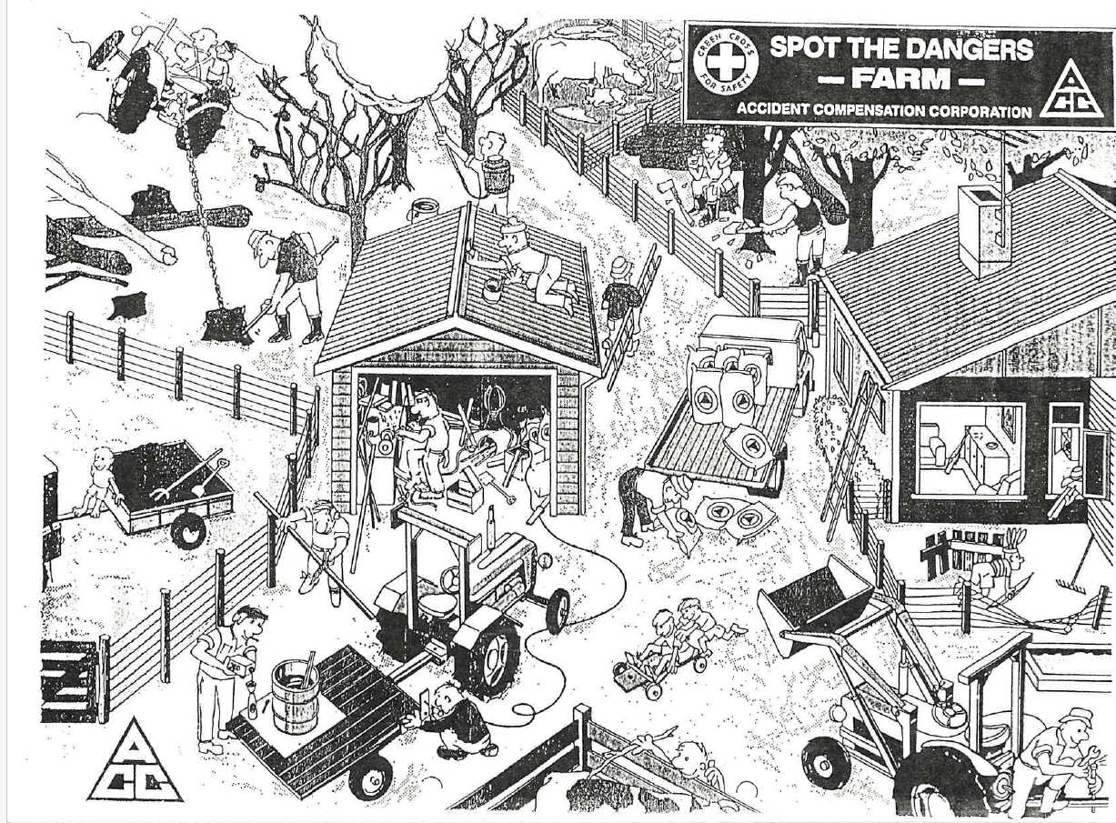**SPOT THE DANGERS ON FARM**

**In groups**

* Spot the dangers on farm
* Discuss why are they dangers?
* What should they be doing to keep safe?

**Hazards**

* Child sitting on the tractor
* No safety frame on the tractor
* Man spraying without safety gear
* Spraying onto other people
* Spraying fruit
* Woodsman’s axe handle broken
* Man lifting sacks straining back
* Rifle and bullets in sitting room
* Man’s rasp has no handle
* Poisons in house accessible
* Children playing with gun
* Rake prongs upward
* Fence down for children
* No PTO cover on tractor
* Child poking cattle
* Tools not secure inside trailer
* Front end loader is up & could fall
* Children amongst cattle in bare feet Man drilling outside with no transformer
* The flex under, over and around obstacles
* Men grinding and drilling not wearing safety glasses
* Child sitting on the trailer has bare feet
* Man pouring chemicals into an ordinary bottle and is smoking and not wearing safety glasses or gloves
* Hammering with a spanner that could fly out
* Trailer not hooked up firmly with a pin
* Children on a trolley playing where there are vehicles and equipment
* Cow not dehorned - especially as it has a calf
* Oher woodsman chopping onto someone
* Roof painter’s ladder has been removed