**Lifting Calves**

Calving is a very busy time on dairy farms, and it is when many injuries can happen. During this time, farmers are often rushing to get jobs done. One of the tasks is lifting calves in wet conditions which can lead to accidents like slips, trips, falls, or back injuries.

When lifting calves, use the correct technique as it can reduce the risk of back injuries.

To lift, squat down beside the calf, pull it in close with one arm around the front and the other around the hind legs. Straighten your knees to lift it. Hold it firmly and do not let it struggle loose. Calves quickly grow and become very heavy. No one should lift a calf if it is too heavy for them.

1. Watch the video Safety tips for [calf pick up](https://www.dairynz.co.nz/people/employment-admin-and-legal-requirements/health-and-safety/)
2. Make a list of what farmers could do to reduce the risk of back injuries before and during calving.

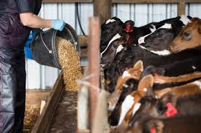

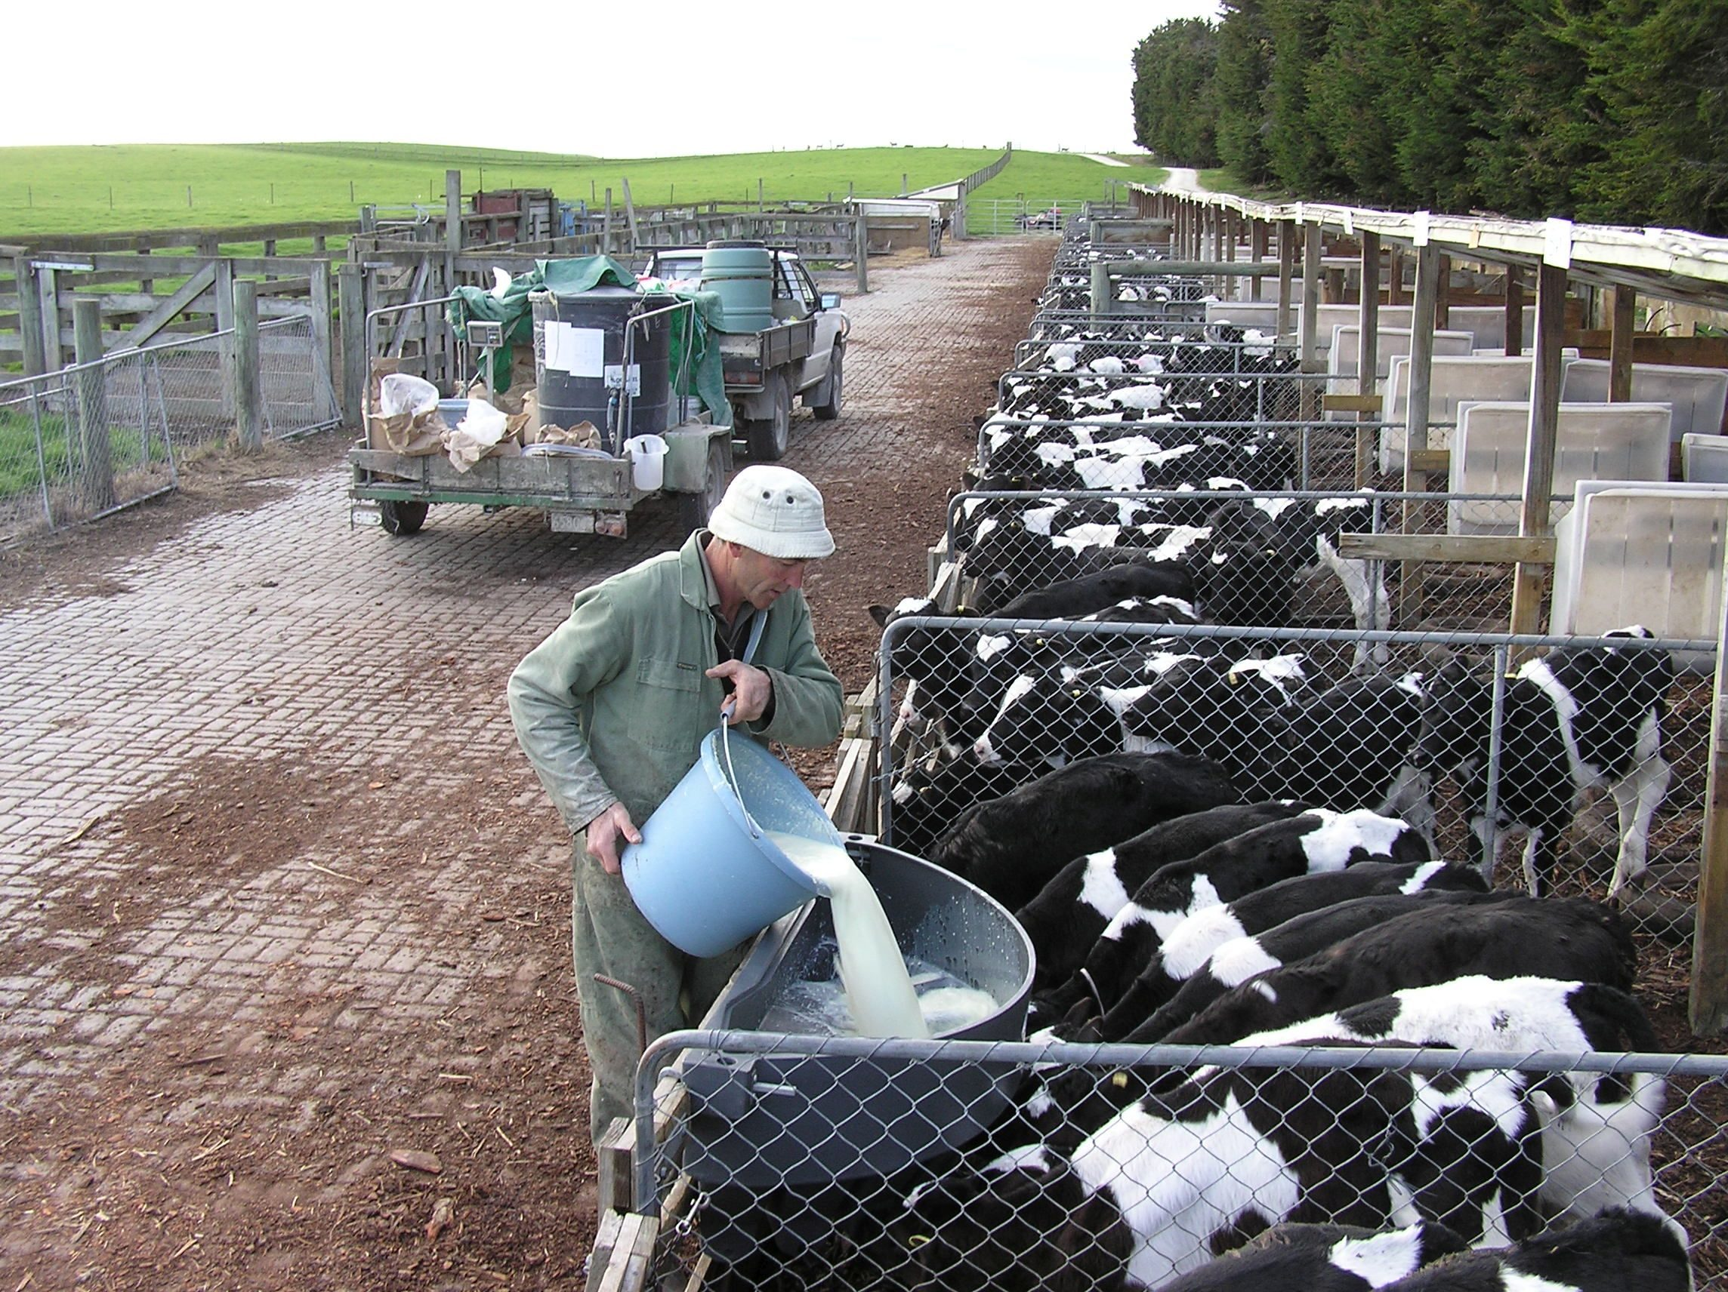

**Suggestions**

* Have two staff pick up heavier calves together if needed.
* Use a specialised trailer to transport calves.
* Pipe milk into calf feeders instead of lifting buckets.
* Tuck hoses away after use in the milking shed.
* Invest in the right footwear - look for great grip and ankle support.
* Farmers also suggested holding quick weekly team meetings to identify risk areas on-farm. For example, any holes or dips that could be a hazard for staff working at night during calving, or how to make calf pick-up easier and avoid heavy lifting.