Colour In and Label the Flower
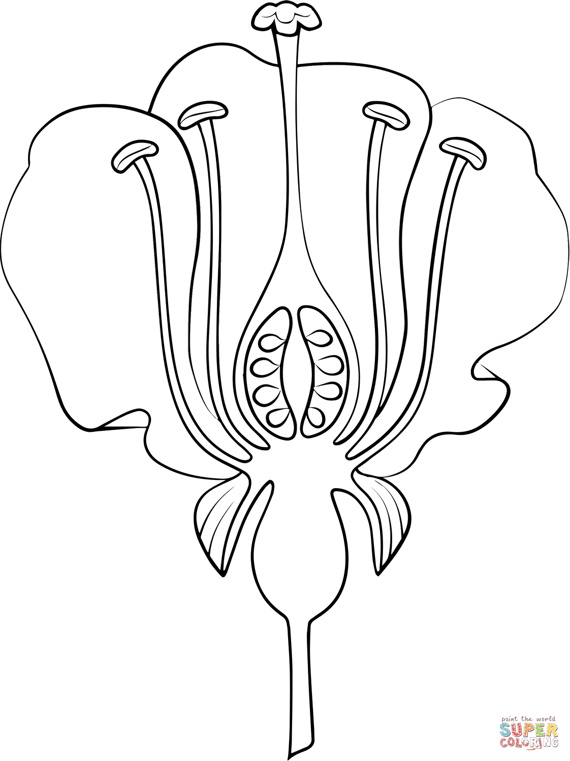
Stigma
Petal
Anther
Style

Filament
Ovary
Ova/eggs

Stem
Part | Function
Petal | To attract bees
Stem | To hold the flower up
Female parts
- Stigma | Sticky so that pollen sticks to it
- Style | Holds the stigma up to catch pollen
- Ovary | Holds the ova
- Ova/eggs | The eggs that will become seeds
Male parts
- Anther | Makes pollen to fertilises ova
- Filament | Holds the anther up

