**Name:**

# Primary Industry Wordfind

|  |  |  |  |  |  |  |  |  |  |  |  |  |  |  |  |  |  |
| --- | --- | --- | --- | --- | --- | --- | --- | --- | --- | --- | --- | --- | --- | --- | --- | --- | --- |
| H | A | A | P | T | M | V | V | F | K | Y | I | E | L | D | A | G | Y |
| F | O | G | K | L | R | H | H | I | E | K | O | J | I | F | Q | L | B |
| E | I | R | R | I | O | A | V | A | T | N | G | C | R | A | U | Z | A |
| R | S | Y | T | I | W | U | C | F | R | I | C | E | M | R | A | S | R |
| T | P | I | P | I | C | I | G | T | L | V | C | E | T | M | C | A | L |
| I | A | A | L | A | C | U | F | H | O | A | E | U | F | E | U | L | E |
| L | V | W | S | A | D | U | L | R | O | R | R | S | L | R | L | M | Y |
| I | I | G | H | T | G | D | L | T | U | Z | O | A | T | T | T | O | P |
| S | Z | P | Z | E | U | E | O | T | U | I | B | P | B | X | U | N | N |
| E | E | J | N | Y | A | R | A | C | U | R | T | P | I | L | R | R | H |
| R | C | R | O | P | S | T | E | F | K | R | E | I | B | F | E | S | E |
| B | J | W | M | Q | Z | J | E | S | J | F | E | P | A | T | L | P | N |

Find the following words in the puzzle. Words are hidden and .

HORTICULTURE AGRICULTURE VITICULTURE AQUACULTURE FERTILISER KIWIFRUIT PASTURE

HARVEST PADDOCK TRACTOR BARLEY ARABLE FARMER PLOUGH

SILAGE SALMON FENCE WHEAT YIELD CROPS

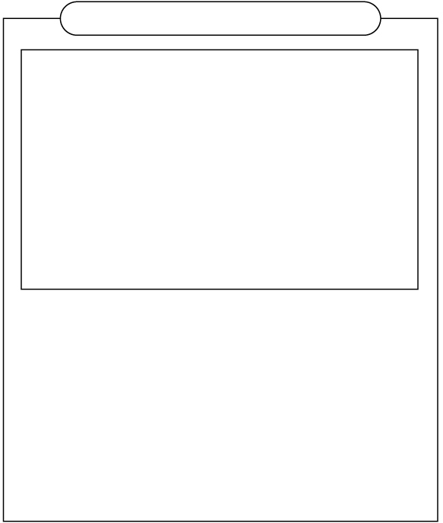

Created by HATA using Word Search Generator on

Super Teacher Worksheets ([www.superteacherworksheets.com](https://www.superteacherworksheets.com/))

**SOLUTION**

# Primary Industry Wordfind

|  |  |  |  |  |  |  |  |  |  |  |  |  |  |  |  |  |  |
| --- | --- | --- | --- | --- | --- | --- | --- | --- | --- | --- | --- | --- | --- | --- | --- | --- | --- |
| H | A | . | P | T | . . | | V | F | . | Y I E L | | | | D | A | . . | |
| F | O | G | K | L | R . | | H | I | E | . . . . | | | | F | Q | . B | |
| E | . | R | R | I | O A | | . | A | T | N . . . | | | | A | U | . A | |
| R | S | . | T | I | W U | | C | . | R | I C . . | | | | R | A | S R | |
| T | P | I | P | I | C | I | G | T | . | V | C | E | . | M | C | A | L |
| I | . | A | L | A | C | U | F | H | O | A | E | U | . | E | U | L | E |
| L | . | W | S | A | D | U | L | R | . | R | R | S | L | R | L | M | Y |

I . . H T G D L T U . . A T T T O . S . . . E U E O T U I . . B . U N .

E . . . . A R . C U R T . . L R R . R C R O P S T E . K R E . . . E . E

. . . . . . . . . . . E . . . . . .

Word directions and start points are formatted: (Direction, X, Y)

HORTICULTURE (SE,1,1) AGRICULTURE (SE,2,1) VITICULTURE (SE,8,1) AQUACULTURE (S,16,1) FERTILISER (S,1,2) KIWIFRUIT (SE,4,2) PASTURE (SE,2,5)

HARVEST (SE,8,2) PADDOCK (SE,4,5) TRACTOR (SE,5,1) BARLEY (S,18,2) ARABLE (SE,11,6) FARMER (S,15,2) PLOUGH (SE,4,1)

SILAGE (SE,2,4) SALMON (S,17,4) FENCE (SE,9,1)

WHEAT (SE,3,7)

YIELD (E,11,1)

CROPS (E,2,11)



Created by HATA using Word Search Generator on

Super Teacher Worksheets ([www.superteacherworksheets.com](https://www.superteacherworksheets.com/))