**Name:**

# Equine Industry

|  |  |  |  |  |  |  |  |  |  |  |  |  |  |  |  |  |  |
| --- | --- | --- | --- | --- | --- | --- | --- | --- | --- | --- | --- | --- | --- | --- | --- | --- | --- |
| C | Y | O | A | T | S | S | J | I | C | H | E | S | T | N | U | T | J |
| R | D | E | R | I | D | E | T | F | D | B | A | Y | V | E | S | R | B |
| T | N | G | A | L | L | O | P | A | V | T | O | C | E | Q | A | E | X |
| V | Z | H | O | R | S | E | P | A | L | A | P | F | U | U | D | I | Z |
| J | B | B | G | H | A | Y | F | O | S | L | I | T | T | E | D | N | S |
| U | O | K | R | G | O | P | E | V | T | L | I | R | N | S | L | S | H |
| M | Q | C | T | I | M | A | R | E | I | U | J | O | B | T | E | P | O |
| P | M | M | K | R | D | Q | A | U | R | H | T | P | N | R | J | D | E |
| F | A | E | X | E | O | L | I | N | R | O | A | H | H | I | X | I | O |
| P | N | D | D | J | Y | T | E | W | U | O | C | Y | G | A | X | Y | L |
| Z | E | S | T | A | B | L | E | D | P | F | K | T | I | N | H | A | C |
| T | E | V | R | F | O | A | L | Y | L | I | Z | G | U | M | J | X | R |

Find the following words in the puzzle. Words are hidden and .

EQUESTRIAN STALLION CHESTNUT STIRRUP BRIDLE JOCKEY STABLE GALLOP

SADDLE TROPHY HORSE REINS FOAL MARE MANE TACK

TROT JUMP SHOE RIDE HOOF OATS BAY HAY

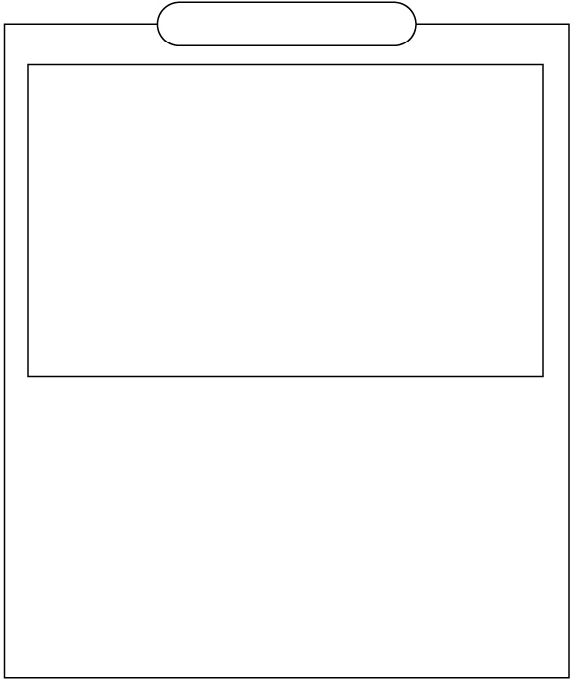

Created by HATA using Word Search Generator on

Super Teacher Worksheets ([www.superteacherworksheets.com](https://www.superteacherworksheets.com/))

**SOLUTION**

# Equine Industry

. . O A T S S . . C H E S T N U T .

. . . R I D E T . . B A Y . E S R .

. . G A L L O P A . . . . . Q A E .

. . H O R S E . . L . . . . U D I . J . B . H A Y . . S L . T . E D N S

U O . R . . . . . T . I R . S L S H M . C T I M A R E I . . O . T E . O P M . K R D . . . R H T P N R . . E

. A . . E O L . . R O A H . I . . .

. N . . . Y T E . U O C Y . A . . .

. E S T A B L E . P F K . . N . . .

. . . . F O A L . . . . . . . . . .

Word directions and start points are formatted: (Direction, X, Y)

EQUESTRIAN (S,15,2) STALLION (SE,7,1) CHESTNUT (E,10,1) STIRRUP (S,10,5) BRIDLE (SE,3,5) JOCKEY (SE,1,5) STABLE (E,3,11) GALLOP (E,3,3)

SADDLE (S,16,2) TROPHY (S,13,5) HORSE (E,3,4)

REINS (S,17,2)

FOAL (E,5,12)

MARE (E,6,7)

MANE (S,2,8)

TACK (S,12,8)

TROT (SE,4,7)

JUMP (S,1,5)

SHOE (S,18,5)

RIDE (E,4,2)

HOOF (S,11,8)

OATS (E,3,1)

BAY (E,11,2)

HAY (E,5,5)



Created by HATA using Word Search Generator on

Super Teacher Worksheets ([www.superteacherworksheets.com](https://www.superteacherworksheets.com/))