How to Prepare a Marketing Budget

1. What Will the Marketing Budget be Based on?
It can be based on several sales calculations:
- Percentage of future or projected sales.
- Percentage of past sales.
- Percentage of current sales.
- Seasonality adjustments for spikes in demand for busier times of year.

2. How Will the Marketing Budget be Measured?
Measure the results of your marketing approaches by tracking how many customers those plans bring in and how much business comes as a result.

3. Deciding What & Where to Spend
For companies that have existing budgets, it’s rather easy to determine the amount to spend relative to the marketing approach. However, it’s simply not the same for new businesses. So, where does this information come from? Well, in the case of new businesses, it really amounts to making some factual assertions. These factual assertions can come from industry sources that provide relevant information on a given market. This could come from trade magazines, industry newsletters or internet research.Initial budgets always involve some aspect of guess work. However, mitigating that guess work is done by making factual assertions based on solid information.

4. Establishing the Budget Itself

- Estimate the costs of implementing your marketing plan over a suitable time period. You should show an expected return on investment through various sales forecasts.
- Estimate the budget you will need to implement your marketing strategies over a suitable time period. This might be short-term (up to 6 months) or medium-term (from 6 months to 2 or more years).
- The forecasts should link cohesively to the smart marketing objectives and must align with findings from the marketing audit and strategy of the firm overall for Excellence.
- You must include a justified assessment around sales forecasts and state any assumptions you have made to justify each income or expense to explain why you have them.

Example 1
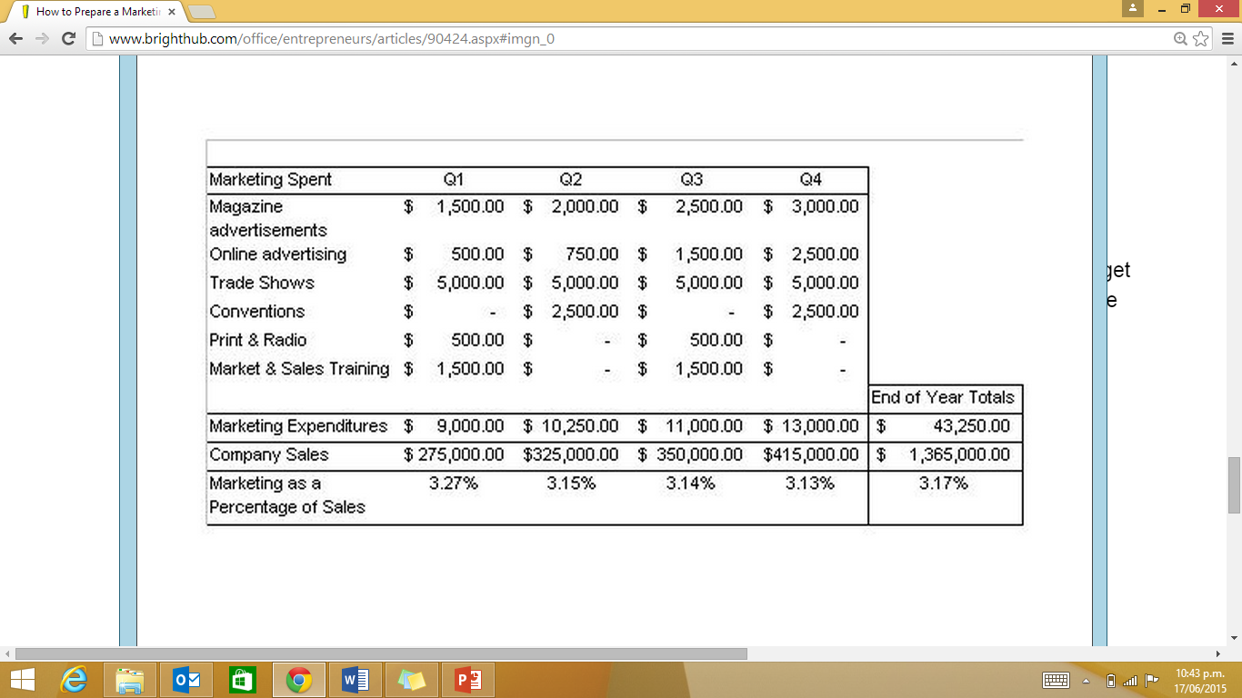
In this example, the marketing budget is based as a percentage of sales by quarter. It is summarized as the total expenditures by quarter on magazine advertisements, online advertising, trade shows, conventions, print & radio as well as miscellaneous marketing & summed up at the bottom of each quarter. The company’s sales for that quarter are just below, and below that is the marketing expenditure expressed as a percentage of sales. The calculation is done by taking total marketing expenditures and dividing it by the company’s sales for that quarter.

Example 2

 | 2015 | 2016
Estimated Receipts:
(Sales- this could be broken up by product/region/brand).
Less Estimated Payments:
- Product development
- Advertising
- Sales Promotion
- Distribution costs
- Market research
- Sponsorship
Total Estimated Payments
Net Surplus/Deficit
Return as a Percentage of Sales

Contingency Plans/ ‘What-If Plans’

Include some alternative plans to implement if results are not as expected in order to still meet your marketing objectives. e.g. what if your main supplier becomes unavailable? Do you have other options? What if you have a product you can’t sell?
Include “what-if” questions and answers for each of the 4P’s.
4 P’s | What –if questions | Answers
Product
Price
Place
Promotion
The contingencies should link cohesively to the smart marketing objectives (new objectives) and findings from the marketing audit for Excellence. Contingencies should also refer to addressing those threats evaluated in the audit [not just sales, but those that pose the most significant risk of failure of the strategy].

Action Plan for implementation
Include a timeline of activities (plans & programmes) including how and when marketing strategies will be implemented for the 4P’s which are required to deliver the marketing objectives. Also demonstrate how and when you will record and collect data to monitor the success of the plan. Also explain how it will be used.

Example
Timeline (when and how market activities will be implemented) Over the 2 year period. |  | How and when will you record and collect data to monitor success of the plan, that is, what market research (primary & secondary) will need to be done to see how the marketing strategies are going. | How will it be used.  Identify the key performance indicators [based on corporate objectives & marketing aims] that would be used to evaluate the overall success of the marketing plan and for future monitoring of the effectiveness of the marketing plan.
Month | Year 1 Year 2  Include plans & programmes for the 4P’s, including how and when marketing strategies will be implemented.  Establish & explain the process & measures for monitoring the ongoing success of your marketing plan.
Jan
Feb
Mar….
Dec

Maori Concepts

State how Maori business terms could be incorporated into your Marketing Plan where relevant. Concepts likely to be relevant include: Putake, Tikanga, Turanga, Kaitiakitanga & Rangatiratanga.

Appendix
Any additional material from your research that the reader of the report may want to refer to (marketing audit research may be relevant to include in this section as well as Pictures & specification of Products)
Bibliography
Your reference section.

