**Bromoform and Methane Reduction**

<https://ch4global.com/resources/#casestudies-whitepapers> (has videos and more information)

Cow stomachs contain micro-organisms called methanogens, which combine hydrogen with carbon dioxide to produce methane and water. The methane, or CH4, is released when the [animal burps](https://www.stuff.co.nz/environment/climate-news/300709100/from-fertiliser-and-cow-burps-to-native-bush-how-farmers-will-pay-for-their-emissions).

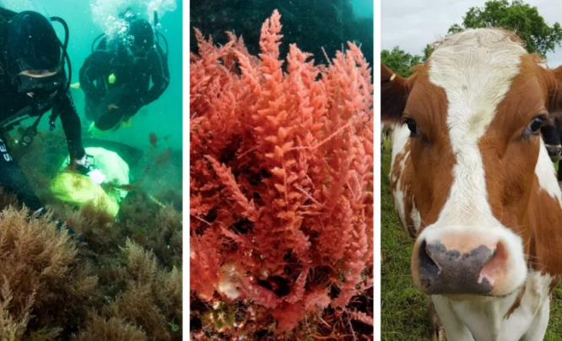A single cow can belch out 100kg of methane a year, which has the same climate impact as about 2500kg of CO2.

Asparagopsis seaweed contains high levels of the chemical bromoform(CHBr3). Bromoform has been found to inhibit the action of two key enzymes in the methanogenic pathway which inhibits methane production. When fed to cattle, it can reduce the levels of methane gas produced during rumination.  This helps combat climate change by addressing a major source of agricultural greenhouse gases.

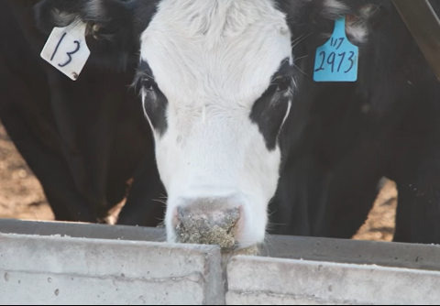**Case Study – CH4 Global, South Australia**

70 head of cattle were fed Methane Tamer™ for 100 days at a feedlot in South Australia. Heath adds in the seaweed extract to his supplementary feed which the cows then eat. He has found that this feed additive formulation was shown to reduce enteric methane by as much as 90%.

**Case Study – SeaForests, Tasmania**

Gardner is a dairy cow farmer in Tasmania with 900-odd dairy cows. He uses Sea Forest’s asparagopsis supplement. This supplement has the bromoform infused into canola oil. Gardner then sprays about 100ml of oil on to the supplementary grain he feeds the cows once a day in the milking shed. Due to the difficulties in measuring methane levels in the paddock, he used the theory that making methane wastes energy, so if you stop that process cows should eat less, without losing weight. In his second trial, the 200 cows fed seaweed oil ate almost 10% less than the 200 control cows, and the cows maintained weight and produced similar levels of [milk](https://www.stuff.co.nz/business/farming/125442629/the-business-of-milk-explained). Gardner was encouraged with the results, however at the current cost of just less than $1 per cow per day, it won’t be affordable without subsidies.

There are currently 5 different thoughts on delivering bromoform to cows:

* Feeding whole seaweed biomass as a mixed ration with feed
* Feeding freeze-dried seaweed as a mixed ration with feed
* Feeding a canola oil emulsion of seaweed with or without the algal biomass removed
* Synthetic bromoform as liquid mixed with feed (with or without stabilizing excipients)
* Synthetic bromoform in a slow-release bolus inserted into the animal’s rumen

For the NZ dairy industry, where cows spend about six minutes in milking sheds twice a day, it has some concern.

* How to ensure the cows are administered the correct dose
* Long-acting supplements because cows graze for 6-8 hours after milking, and that's when methane is produced
* Some trials have residues of bromoform detected in the milk
* Further research is needed to determine whether residues of bromoform accumulate in the muscle or organ tissues of animals being supplemented with Asparagopsis
* Bromoform toxicity

**Questions**

1. How do cows produce methane gas?
2. Why is methane gas an important Greenhouse Gas for dairy farmers?
3. How does bromoform affect methane production?
4. What are the advantages and disadvantages of using Asparagopsis in cows.
5. Would you recommend using Asparagopsis in a dairy herd? Why/why not?

**Discuss the benefits and challenges of using Asparagopsis seaweed supplements in dairy farming.**

**Question:** Discuss the advantages and limitations of feeding Asparagopsis seaweed supplements to dairy cows.  
**Answer:**  
**Benefits:**

* **Methane Reduction:** Trials have demonstrated reductions in methane emissions by up to **90%**, addressing a major source of agricultural greenhouse gases.
* **Improved Efficiency:** Methane production wastes energy. By inhibiting this process, cows may require less feed while maintaining weight and milk production, as seen in trials where feed consumption decreased by **10%**.

**Challenges:**

* **Cost:** The current cost of supplements is around **$1 per cow per day**, making it financially unsustainable without subsidies.
* **Administration Issues:** For grazing dairy cows, ensuring consistent dosing is difficult, especially since methane is produced during extended grazing periods.
* **Residue Concerns:** Trials have detected bromoform residues in milk, and further research is needed to understand its potential accumulation in meat or organs.
* **Toxicity:** Long-term effects of bromoform supplementation on animal health and food safety require further investigation.