**Growing Lettuce in New Zealand**

Lettuce is one of New Zealand’s most popular vegetable crops. It is mainly grown for local markets, but a small amount is exported. Lettuce is fast-growing and can be grown in areas with mild to temperate climates. Challenges like weather, pests, and labour shortages can impact on the profitability of production but new farming methods and technology are helping growers improve productivity and sustainability.

Main Growing Regions

* Canterbury - the largest region for lettuce production, especially in the winter months
* Hawke’s Bay - particularly in the warmer months
* 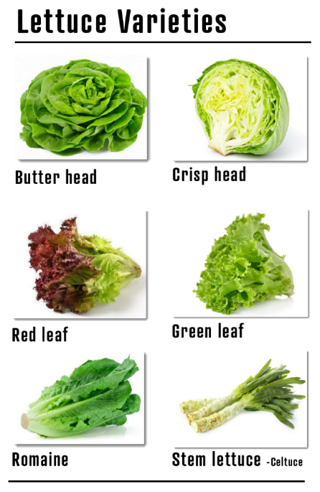Auckland - also a key region for growing lettuce, especially for the local market

Growing Lettuce

1. Planting: usually grown from seeds either planted directly into the soil or started in seed trays before being transplanted. Lettuce grows quickly and is usually ready for harvest in about 6-8 weeks.
2. Types of Lettuce:
   * Iceberg - crunchy and popular in salads
   * Cos (Romaine) - also used in salads and sandwiches
   * Butterhead - soft and tender with a mild flavour
3. Growing Conditions: lettuce tends to prefer cooler temperatures, so is often grown in the spring and autumn. However, in warmer regions like Hawke’s Bay it can also be grown during the summer.
4. Harvesting: usually harvested by hand when the heads are full and firm. Leafy varieties need to be carefully picked to avoid damage.

Considerations

* Lettuce is sensitive to extreme weather. Too much rain, frost, or heat can affect the quality of the crop. For example, hot weather can cause lettuce to "bolt," or go to seed, which makes it tough and bitter.
* Pests and diseases like aphids and downy mildew can affect lettuce and growers need to manage these to ensure healthy crops.
* Labour shortages, like much of the horticultural industries is an issue, growing lettuce requires a lot of hands-on work especially during planting and harvest.
* New technologies like smart greenhouses can streamline and increase production and protect the plants from weather and pests. Automated systems for planting, watering, and harvesting saves time and reduces labour costs.
* Using sustainable practices, such as reducing pesticide use through Integrated Pest Management (IPM) and improving water efficiency are common management practices. Many growers grow using hydroponics.

<https://tuigarden.co.nz/how-to-guide/lettuce-growing-guide/>

<https://www.yates.co.nz/plants/vegetable/lettuce/how-to-grow-lettuce/>