Overview of New Zealand Arable Farming Industry
Arable farming in New Zealand mainly happens in the Canterbury region, where most of the country’s wheat and barley are grown. Farmers typically rotate crops like wheat, barley, peas, and some seed crops like carrots, ryegrass and clover over several seasons.
Main Crops
- Wheat: Wheat, sown in Autumn usually, makes up 17% of all crops grown
- Barley: A large portion of barley production happens in Canterbury
- Maize: Maize is an important crop in the North Island, especially for dairy farms
- Greenfeed & Silage Crops: Are grown for livestock feed and make up 21% of all crops
Markets and Exports
New Zealand’s arable crops are sold both domestically and to other countries.
- Grains like wheat and barley are used in making flour and animal feed.
- Some special crops, like durum wheat for pasta, are grown for export.
- Research is being done on extracting protein from peas, beans, and other pulses to export.
Future Challenges
Challenges the industry faces:
- Soil Management: issues like erosion and compaction, and potentially a decrease in available land with quality soils, and decreasing soil health.
- Climate Change: unpredictable weather means preparation and awareness around the environmental, social, and economic impacts of climate change is needed. Better soil protection practices and support for reducing greenhouse gas emissions to align with NZ's commitments to climate change and reducing greenhouse gases is also needed.
- Resource Management: guidelines and support to improve water and nitrogen use.
- Diversification: ways to make farms more flexible and sustainable, with a focus on both profit and the environment.
Arable Farming in New Zealand
The North Island grows more maize, while the South Island grows mostly wheat and barley.
North Island
- Manawatu/Wairarapa: Grows a wide range of crops.
- Auckland/Waikato & East Coast: Focus on crops that suit their specific climates.
- Maize: This crop is especially important in the North Island.

South Island
- Canterbury: The main region for arable farming, making up most of the wheat and barley production. It grows 82% of New Zealand's wheat and 68% of its barley, plus other crops like peas and ryegrass (for seed).
- Marlborough: Growing most NZ’s clover seed.
- Otago & Southland: Also have widespread arable farming.
Recent Developments in Arable Farming
Globally:
- Conservation or Minimum Tillage: more farmers are using less cultivation and tilling to prevent overcultivation of the soil.
- Precision Agriculture: technology like GPS and farm management software are becoming more common to help improve efficiency and reduce nutrient losses.
- Crop Diversity and Rotation: farmers are growing more varied crops, like pulses and oilseeds, to help the soil and their income.
In New Zealand:
- Less Tillage: farmers using methods like direct drilling, reducing the amount of cultivation.
- Longer Crop Phases: crops are being grown for longer periods, with fewer rest (fellow) periods.
- Crop Diversity: farmers are growing more types of crops, including cereals, pulses, and vegetable seeds. Changing crops and crop rotation helps keep soil healthy and reduces the need for fertilisers and pest control. It also reduces economic risk and can improve soil health.
- Higher Yields: yields are improving, for example wheat yields rising from 6.5 tons per hectare in 2004 to 9.5 tons per hectare in 2024 (see graph below).
- Technology: use of new technologies, like GPS and variable-rate fertiliser or irrigation application help planting and managing crops more accurately, saving time and money.
- Livestock and Crops: an increased focus on growing crops for animal feed, like silage for dairy farms.
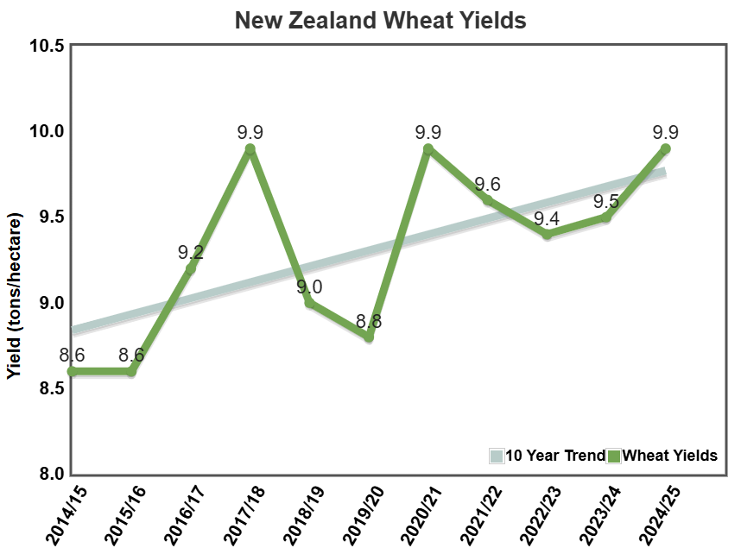

Question Worksheet
Short Answer Questions
- Where is New Zealand's arable farming industry mainly located?
- What are two main crops grown in New Zealand's arable farming industry?
- What is the main purpose of growing greenfeed and silage crops in New Zealand?
- Which region of New Zealand grows the most wheat and barley?
- What is the primary use for grains like wheat and barley in New Zealand?
- How is climate change affecting New Zealand’s arable farming industry?
- What type of farming system is becoming more common in New Zealand, reducing tillage and ploughing?
- Which crop is important for arable farming economics in the North Island?
- What is one benefit of growing a wider variety of crops in arable farming?
- How has wheat yield changed in New Zealand from 2004 to 2024?

Longer Answer Questions
- Explain the role of Canterbury in New Zealand’s arable farming industry. Include information about the crops grown there and the region’s importance to wheat and barley production.
- Describe the challenges New Zealand’s arable farming industry faces in terms of soil management and climate change. How are these issues being addressed?
- How is technology, such as GPS and precision agriculture, being used in New Zealand's arable farming? Explain the benefits of these technologies for farmers.
- Discuss the importance of crop rotations in New Zealand's arable farming. What are the advantages of rotating crops like wheat, barley, peas, and clover?
- What are some recent changes in arable farming in New Zealand? How have farming practices and crop types changed over the years, and why?
- Explain the future-proofing strategies that New Zealand’s arable farming industry is exploring. How do these strategies aim to make farming more sustainable and profitable in the long term?
- Compare and contrast the arable farming systems in the North Island and South Island of New Zealand. What are the main differences in crops grown and farming practices in these two regions?
- What are some of the global trends in arable farming, and how are they influencing farming practices in New Zealand? Give examples of trends such as conservation tillage or crop rotations.

Short Answers

  - Where is New Zealand's arable farming industry mainly located? In the Canterbury region.
  - What are two main crops grown in New Zealand's arable farming industry? Wheat and barley.
  - What is the main purpose of growing greenfeed and silage crops in New Zealand? They are grown to support livestock, providing feed such as silage for animals like dairy cows.
  - Which region of New Zealand grows the most wheat and barley? Canterbury.
  - What is the primary use for grains like wheat and barley in New Zealand? They are used in the domestic flour milling industry and feed manufacturing industry.
  - How is climate change affecting New Zealand’s arable farming industry? Farmers need to prepare for the environmental, social, and economic impacts of climate change, and work to reduce greenhouse gas emissions.
  - What type of farming system is becoming more common in New Zealand, reducing tillage and ploughing? Crop rotation and minimum tillage like direct drilling.
  - Which crop is important for arable farming economics in the North Island? Maize (corn).
  - What is one benefit of growing a wider variety of crops in arable farming? Crop diversification helps improve soil health, can provide economic security/benefits.
  - How has wheat yield changed in New Zealand from 2004 to 2024? The average wheat yield increased from 6.5 tons per hectare in 2004 to 9.5 tons per hectare in 2024.

Long Answers

- What is the role of Canterbury in New Zealand’s arable farming industry?
Canterbury is the biggest area for growing crops in New Zealand. It produces 82% of the country's wheat and 68% of its barley. The region also grows other crops like peas, ryegrass, clover, and small vegetable seeds. These crops are important for making flour and animal feed.
- What challenges does New Zealand face with soil management and climate change? How are these issues being fixed?
New Zealand has problems with soil erosion, soil compaction and keeping soil healthy. Climate change causes unpredictable weather, and farmers are getting ready for these changes by using better practices and working to reduce greenhouse gases.
- How is technology like GPS and precision agriculture helping New Zealand farmers?
GPS and precision farming tools are used to make their work more accurate. For example, GPS helps with planting, fertilising, and harvesting crops. This saves time and money and helps make farming more efficient and sustainable.
- Why is crop rotation important in New Zealand’s arable farming?
Crop rotation is important because it helps reduce pests and diseases. By changing crops like wheat, barley, peas, and clover, soil pests’ life cycle is broken and some crops such as legume can increase Nitrogen levels in the soil which helps reduce the need for fertilisers.
- What changes have happened in New Zealand’s arable farming in recent years?
Using less tillage, meaning they are disturbing the soil less. Also planting crops for longer periods and using more diverse crops, such as pulses and vegetable seeds. These changes help improve soil health and increase crop yields.
- What future-proofing strategies is New Zealand’s arable farming industry using?
Focusing on sustainable farming, improving soil health, and adapting to climate change. Farmers are working to reduce greenhouse gas emissions and grow different crops to ensure they stay profitable and protect the environment in the long term.
- What are the main differences between arable farming in the North and South Islands of New Zealand?
The North Island grows a wide range of crops, especially maize. Areas like Manawatu/Wairarapa have good conditions for many crops. The South Island, especially Canterbury, is known for growing wheat and barley. The South Island focuses more on cereals and pasture crops, while the North Island grows more maize.
- What are some global trends in arable farming, and how are they affecting New Zealand’s farming?
Global trends like no-till farming, better crop rotations, and using precision farming tools are changing how farmers work. In New Zealand, these trends are helping farmers use less water, reduce soil damage, and grow a wider range of crops. This improves farm efficiency and sustainability.

