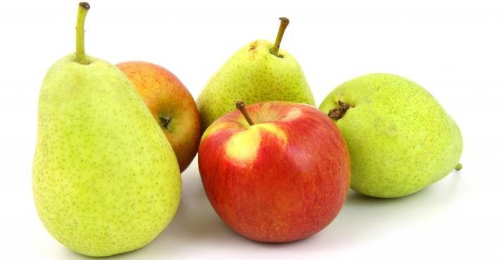**A Summary of the Apple and Pear Industry in New Zealand**

New Zealand is known for producing high-quality apples and pears. The industry plays an important role in the economy as most of the fruit is exported. Growers focus on quality, sustainability, and innovation and this ensures NZ is competitive on the global market.

**Industry Overview**

* Key Players: Some of the largest companies in the industry include *Turners & Growers*, *ENZA*, and *T&G Global*. However, many small, family-owned orchards also produce apples and pears.
* Main Growing Regions: The main areas where apples and pears are grown include:
  + Hawke's Bay - this is the largest and most important region for apple and pear production
  + Nelson – produces the majority of Royal Gala
  + Waikato and Canterbury - these regions also grow apples and pears, although not as much as Hawke's Bay
* Exports: Most of New Zealand’s apples and pears are exported and New Zealand is one of the largest apple exporters in the Southern Hemisphere. Key markets for NZ apples and pears include:
  + Asia (China, Japan, India) - strong demand for high-quality varieties like Royal Gala, Jazz, and Braeburn.
  + Europe - the UK and other European countries are also important markets
  + North America - USA and Canada are major customers of NZ apples
* Economic Importance: The apple and pear industry contributes more than NZD 1 billion each year to New Zealand’s economy. Apples are one of the country's biggest horticultural exports

**Apple Varieties**

New Zealand grows many types of apples, some of the most popular varieties are:

1. Royal Gala - known for its sweetness and crisp texture
2. Braeburn - tangy, firm apple that is popular in Europe and Asia
3. Jazz - a newer apple variety that is a cross between Royal Gala and Braeburn, it has a crisp texture and a sweet/sour flavour balance
4. Granny Smith - the classic green apple known for its tart flavour, often used in cooking
5. Fuji - sweet, firm apple that is popular in Asia

<https://info.applesandpears.nz/our-apples-pears/our-apples/>

<https://teara.govt.nz/en/diagram/25413/jazz-apple-family-tree>

<https://www.mrapple.com/en/our-apples>

**Pear Varieties**

While pears have a smaller export market they are still a key crop. Some of the main pear varieties are:

1. **Bartlett** - a soft, sweet pear that is popular in many markets, especially the UK and Asia
2. **Packham Triumph** - a firm pear with a mild, sweet flavour eaten fresh or used in processed products
3. **D’Anjou** - a smooth, juicy pear that is mainly exported to Europe and Asia

**Trends and Challenges**

* **Sustainability**: Many apple and pear growers are adopting sustainable farming practices including reducing water use, using fewer chemicals, which are important for both the environment and consumer demand for eco-friendly products.
* **Climate Change**: Changes in weather patterns, such as hotter temperatures and more extreme weather events, are affecting apple and pear production.
* **Labor Shortages**: There is a shortage of workers, especially during the busy harvest season. Picking and packing apples and pears are labour-intensive tasks, and many growers face challenges finding enough workers.
* **Market Access and Trade Relationships**: Trade agreements, such as the Comprehensive and Progressive Agreement for Trans-Pacific Partnership (CPTPP), have opened up new markets for New Zealand apples and pears. However, trade barriers, such as tariffs and political tensions, can still impact exports, particularly with countries like China.
* **Innovation**: Focus is on developing new apple varieties that meet changing consumer tastes. Varieties like Jazz and Envy have been successful in the market. Additionally, New Zealand is investing in technology to improve the shelf life and quality of its exported fruit, and automated picking machines to reduce labour shortages.

<https://info.applesandpears.nz/our-apples-pears/our-pears/>

<https://teara.govt.nz/en/photograph/17251/pear-varieties>

**Export Data**

Apples

New Zealand exports a large amount of apples every year:

1. **China**:
   * Exports: ~40,000 metric tons (2023)
   * Share of total apple exports: 25%
   * Popular varieties: Royal Gala, Jazz, Braeburn.
2. **Japan**:
   * Exports: ~28,000 metric tons (2023)
   * Share of total apple exports: 18%
   * Popular varieties: Royal Gala, Braeburn, Fuji.
3. **United Kingdom**:
   * Exports: ~22,000 metric tons (2023)
   * Share of total apple exports: 14%
   * Popular varieties: Braeburn, Royal Gala, Pacific Rose.
4. **United States**:
   * Exports: ~20,000 metric tons (2023)
   * Share of total apple exports: 13%
   * Popular varieties: Braeburn, Royal Gala, Jazz.
5. **Other Asian Markets (e.g., Taiwan, South Korea, India)**:
   * Exports: ~18,000 metric tons (2023)
   * Share of total apple exports: 12%
   * Popular varieties: Royal Gala, Fuji.
6. **Australia**:
   * Exports: ~10,000 metric tons (2023)
   * Share of total apple exports: 7%
   * Popular varieties: Royal Gala, Braeburn, Fuji.

Pears

Pears make up a smaller portion of New Zealand’s exports, but are still important:

1. **United Kingdom**:
   * Exports: ~10,500 metric tons (2023)
   * Share of total pear exports: 26%
   * Popular varieties: Bartlett, Packham Triumph.
2. **China**:
   * Exports: ~8,000 metric tons (2023)
   * Share of total pear exports: 20%
   * Popular varieties: Bartlett, Packham Triumph.
3. **Japan**:
   * Exports: ~7,500 metric tons (2023)
   * Share of total pear exports: 18%
   * Popular varieties: Bartlett, Packham Triumph.
4. **Australia:**
   * Exports: ~6,000 metric tons (2023)
   * Share of total pear exports: 15%
   * Popular varieties: Bartlett, D'Anjou.
5. **Middle East (e.g., UAE, Saudi Arabia)**:
   * Exports: ~5,000 metric tons (2023)
   * Share of total pear exports: 12%
   * Popular varieties: Bartlett, Packham Triumph.
6. **Other European Markets (Germany, Netherlands, France)**:
   * Exports: ~4,500 metric tons (2023)
   * Share of total pear exports: 9%
   * Popular varieties: Packham Triumph, D'Anjou.