**Agribusiness Internal Assessment Resource**

Achievement standard: 91362

Standard title: Demonstrate understanding of the nature of technological outcomes

Level: 2

Credits: 4

Resource title: The nature of drones

Resource reference: Generic Technology - 2.9 v2

Learner instructions

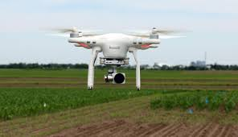

# Introduction

This assessment activity requires you to demonstrate understanding of the nature of drones.

You are going to be assessed on how comprehensively you demonstrate your understanding of the nature of drones.

The following instructions provide you with a way to structure your work so you can demonstrate what you have learnt and achieve success in this standard.

# Task

Prepare a presentation or report that shows your understanding by referring to a range of drones. This might include different styles (for example configuration and colour), features (for example sensors, power supply, actuators) or types (for example, target and decoy, reconnaissance, combat, logistics, research and development and civil and commercial UAVs). The purpose of your report is to brief farmer / growers about the latest technological developments relating to drones.

You will:

* explain functional design elements (for example strength, durability, safety, stability, efficiency, reliability, user-friendliness, and/or ergonomic fit) and how they relate to the functional attributes of drones
* explain physical design elements (for example proportion, balance, style, and/or colour) and how they relate to the physical attributes (style, appearance) of drones
* explain how the physical and functional attributes contribute overall to what drones look like, what they are made of and what they can do
* explain how design elements appear to have been prioritised when designing drones
* discuss how the fitness for purpose of a drone is related to its physical and functional nature and the environment where it will be located.

You could present your understanding as a presentation (for example slideshow, display board, portfolio, pamphlet, video) or as a written report, which could include:

* annotated photos, drawings and/or pictures
* tables.

You could also include a practical demonstration.